Tales of the Al Dorr Family
As told by
Maxyne C. Dorr

INTRODUCTION

The information for the following story is taken from several sources. First and most important were Mother’s notes that I found when I cleaned out her house after she moved to assisted living. For the first few months after she was in the assisted living home, Mom focused on the time she lived in Supply. I was able to obtain additional information by listening to her stories about her childhood. I have been able to obtain a lot of details that otherwise would have been lost.

After reading several of her summaries, I realized that these were written as her testimony of how God had helped her to overcome difficulties in her life. Among these were her father losing the bank, my birth with cerebral palsy and getting five boys through their teenage years. They also contain information on her family and how she met our father. During the late 70’s and early 80’s Mother went to a number of Christian conferences, both in the United States and abroad. There were six to eight different handwritten copies, (I do not believe mother ever learned to use a computer).

I also found a log of our Father’s for the years 1957 to 1985 that included the major events that happened each year. Mother always called Dad "Dorr," and that is how she refers to him in the following story.

TABLE OF CONTENTS

Introduction
Supply
My Family
Growing up in Supply
Lone Wolf
Church Life as a Youth
Dorr’s Family
Early Years as a Youth
Marriage
After College
Ed’s Cerebral Palsy
Perry During the War
Early Years in OKC
Dad’s Business Career
The Wildwood Years
Finding the Lord
Congress on World Evangelism – Lausanne
The Lansbrook Years
Renaissance in Stillwater
Addresses

SUPPLY

I was born on June 11, 1919 in the little town of Supply, OK in the Northwest part of the state. I think it received its name because that is exactly what it was in the early days, a supply center for this somewhat remote area. Also, just about a mile from this little town was a small but well cared for military fort. There were trees planted on both sides of the road to the fort. The fort was an area that was complete in itself. There were no other roads away from the fort except through the little town of Supply. Soldiers who were ill with emotional problems were cared for at this hospital post. In all the years I have visited there everything was neat, clean and well cared for. As the need for the active fort was over, it became mainly a hospital complex for some type of home or medical care.
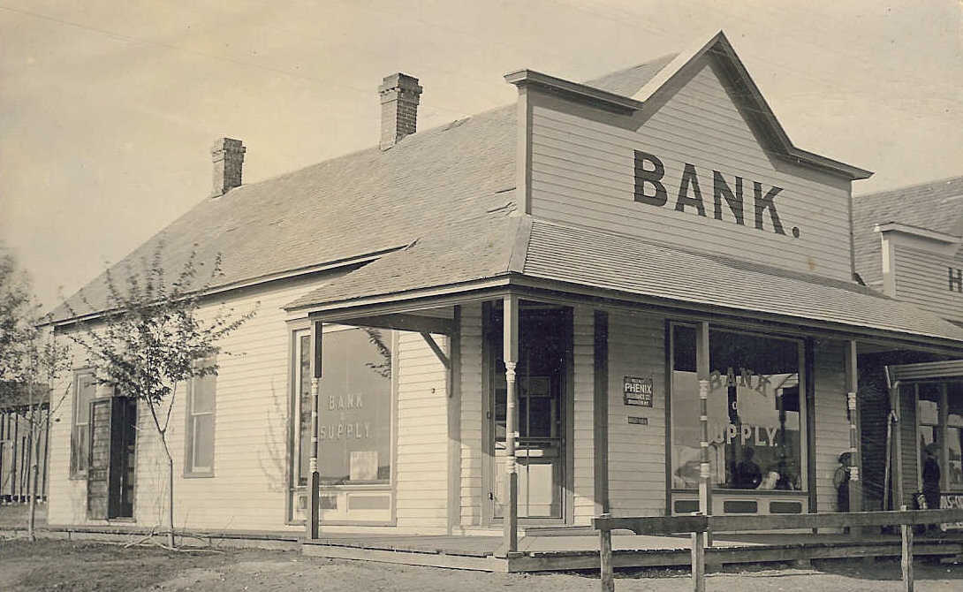
The population of Supply must have been around 250 people (if that many). There were many farms around Supply and people did their Saturday shopping in Supply. Main Street was about three blocks long. There was the Bank of Supply that my family owned. The bank had been founded in 1905 by E. L. Gandy who also owned a large general tore. In 1907 Mr. Gandy sold the bank to E. M. Lowe and T. P Lowe for $500. In 1911 my grandfather, Burrell Million, Sr. bought the bank. And of course, the door to the bank was angled across the corner with the name of the bank and certain assets printed there. All banks back then had their entry door like this. At that time the bank was a wooden structure sometime after 1911 the bank built a new brick building.
Next to the bank was the Davis Drug store and then several vacant lots. Then there was Mr. Cunningham’s barbershop, which received all the business because there was no other barber. Next was a somewhat longer space – then a huge two-story brick building which contained Gandy's, a well-supplied general store. It had a little bit of everything. This building had an elevator inside going to the second story. On the outside was a long wooden stairway, which everyone climbed to go to the weekend dance or some special program that took place there.

Since there weren’t that many opportunities for fellowship, no one minded climbing the long wooden staircase at the general store to the dance floor on the second floor. I remember when a local orchestra was played there. They also played at the auditorium at the hospital about a mile away. Every so often there were dances held in the auditorium area of the large administration building. My family was always invited to these dances and we went a number of times. My daddy would always ask me to waltz with him at least once during the evening. It made me feel so grown up and special.

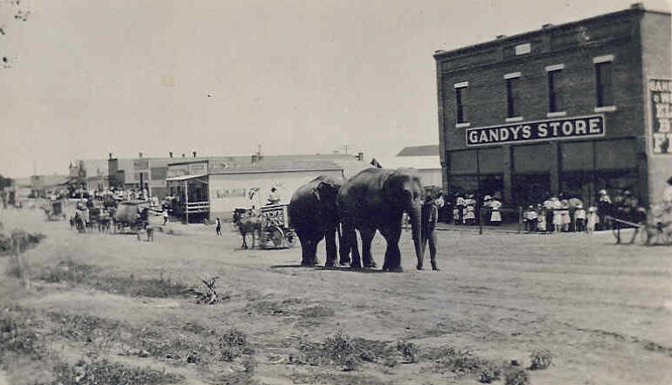
Supply also consisted of a post office, a newspaper and a very small print shop. There was also a very small hotel, one grocery store, one “rooming house,” Hurst’s garage and filling station, one grain elevator and one little train depot just three blocks from the bank corner. There was a small two-story hotel diagonally across Main Street from the bank. There were vacant lots all down this side of Main Street. In about the middle of this area was a well-built little bandstand where on special times or Saturday evenings my brother Don (a teenager then) would sometimes play his trombone and the husband of the postmaster, Red Vaughn, played the drums. They would give us a little jazz festival. A number of cars would show up with various families and park in a row down the middle of Main Street and listen and visit after they had finished their shopping. People sat in their cars and visited with one another with their car doors open or the top folded back.
In October 2002 Ed and Pat took me back to see Supply again. Ed has a friend whose parents live in Supply, Bobbie and Zelda Norman, and they went out of their way to make the trip special. First they contacted a classmate of mine, Barbara Doris Devore, whom I had not seen since I was 11 years old. We both remembered each other and recalled a lot of families who lived there in the 20's. Then we went to city hall where they had information about my family and the bank. Bobbie drove us around to see the town. There is not much there after 70 years, but the bank building is still there and we were able to go inside. It is now apartments, but the fancy ceiling that I remember is still there. The old boarding house and an old church are also still there. There were a few homes there that I remembered including Dr. Stelcher's, the Gandy's and others.
.

My Family

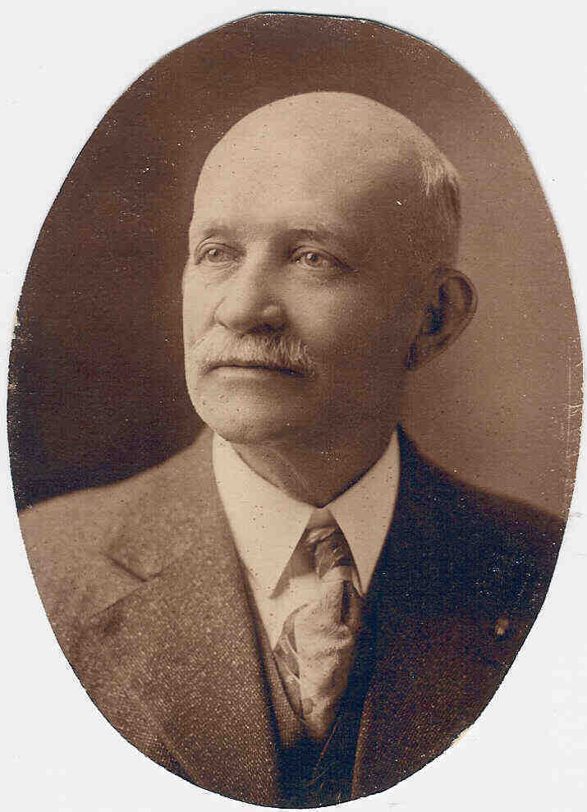
My mother's father, Burrell Million, Sr. was born in 1851 in Monticello, Missouri where he was reared. Members of his family owned a bank, hotel, and other businesses in Monticello. We have canceled checks showing he was in Farber, Missouri before he came to Oklahoma. He came to Oklahoma in 1904, first engaging in the banking business in Apache, then moving to Supply in 1911 where he bought the Bank of Supply. He was the president of the Bank of Supply which he successfully conducted to the time of his death. He led an active business life, giving liberally of both his time and means to the upbuilding of the community. He died in 1920 of heart trouble.
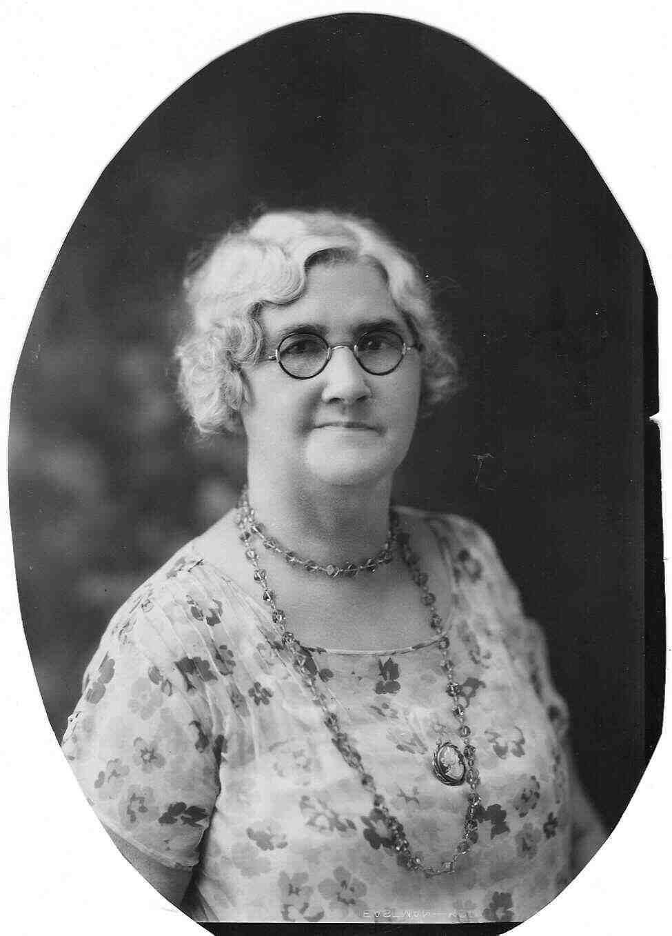
My mother, Ora Million Zerby, was a beautiful, talented, dear woman. She was more of a business woman and society person than a loving mother. Daddy, Percy B. Zerby, was a loving and gentle person with a gift for words. This was a second marriage for both of them. My mother was Catholic and my father a Baptist, which at that time was not the best combination.
Mother was born in Missouri I believe in Williamstown. At least that was where Aunt Ethel was born. She attended a Catholic college at a Catholic convent in Quincy, Illinois. She was originally married to Dr. Arthur Perry. She had Uncle Don and Uncle Sam while married to Dr. Perry. I also believe she lost several babies.

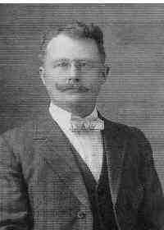
Dr. Perry, my mother's first husband, was practicing medicine in Missouri when my Grandfather Million convinced him to move to Apache. There was no doctor in Apache at the time. Shortly after they moved to Apache some type of epidemic broke out along the Texas/Oklahoma border in the panhandle. Dr. Perry volunteered to go help fight the epidemic. They are not sure what happened but they found him one morning frozen to death in a store he was sleeping in. The front door was open. It was assumed he may have caught the epidemic and was not able to get up and close the door.
My mother had a brother, Burrell Jr. and a sister Ethyl. Burrell Jr. was quite an athlete and played baseball on two different teams which Grandpa was not too happy about.
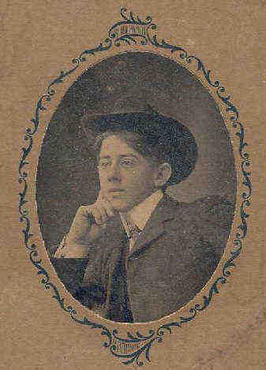
My father, Percy Brandon Zerby, was born February 2, 1885 in Missouri. He had three brothers and three sisters. There are documents showing his family tree going back eleven generations to Mecklenburg in North Germany. I do not remember anything about Daddy’s early years. After mom moved independent living, I came across numerous documents related to her family. The following gives us an insight to his childhood.

Started July 27, 1951
This is a History of My Life written by me in the 65 years of my existence. Written for the information of my sons and my grandsons, my daughter, their wives and husband.
It is written without any intention at literary excellence, but as a single recording of one who I hope has had the affection of those who I love and respect so dearly.
I am the eldest of a family of eight – 5 boys and 3 girls, listed as their births came:
Percy Brandom Zerby (myself), Martin Leander, Harry Lewis, Ross Morris, Sarah Elizabeth, Thomas Edward (died in infancy, the only one that is deceased at this date), Ella Allen, Emily Adeline.
My first remembrance of the stern realities of life and as I look back now from the experience of years is the poverty of the house I lived in and the privations of Father and Mother. I am told that I was 3 months old when with my mother we joined my father in Comanche County, Kansas where he had staked a claim.
My very first recollection is the box trap which my father made to catch what we called snow birds. He sprinkled some small grain on the ground and then propped up the box on a stick to which he had attached a string long enough to reach the door of our sod shanty. When the little birds gathered in large numbers under the box and were busily eating the grain he jerked the string and usually one drop was enough to catch a sufficient number to make an ample snow bird pie which served as our meat for the meals – breakfast, dinner and supper. Even there our poverty as I look back on it was delightfully forgotten by me in the ample satisfaction of a filled stomach.
I recall that fathers would be gone for several days at a time and I would with my mother go out over the prairie and gather Buffalo chips, the name they gave from the dropping of the cattle dung, and this we used for fuel. At last Father would return and he would have a great load of logs which he had gathered in the Oklahoma strip. And by the way this was on the Indian Reservation and near the town of Supply, Oklahoma to which we many years after moved and lived near, the history of which will come later.

While in Kansas Martin and Lewis were born. Finally the rigors and the poverty entailed in this frontier were too stringent for a young wife and 3 small children so we packed our scanty belongings into a covered wagon and made the trip overland to Oklahoma City, Oklahoma. Even there in vigor and location gave promise for the great city that now is the capitol of the State of Oklahoma. Here was born Ross Morris. I remember but very little of our stay there.
(Here get the date we left Oklahoma City? And the reason for leaving?)
However, we again took to the covered wagon and we traveled back to Wakenda, Missouri. My father worked for an uncle of mine, Uncle Ed Brandom. He was the owner of considerable land and had a large two-story house, large farms, a grist mill where he ground corn for his cattle and hogs, mules and horses aplenty. He was a large stock man and kept a large number of steers on full feed all the time we lived there. He was a very resourceful man. He owned a hardware store and flour mill in Wakenda, Missouri which was just a mile north of his ranch.
I go into detail here for the reason that here in this location I received the deep impression of the vicissitudes of life. The generosity and the cruel injustice of human conception in relation to one another even among your relations. Here was an uncle, the brother of my mother, in these days a man of wealth, a religious man. A Deacon in the Baptist Church, Superintendent of the Wakenda Baptist Church. A man of influence and as I recall him a gentle man. But with a mental complex about money that I never understood, as evidenced from a period years after. I had made a trip back to Missouri and bought our house in Supply from the party who owned it and who lived in Missouri. On my way back home I came through Carrollton, Missouri and Uncle Ed was living there with his only daughter. He drove me down to the old house which he still owned and in which his youngest son was now operating. As we passed the old Cary Graveyard where his first wife’s people and in which she was buried, and also his oldest daughter Sadie. The weeds covered the cemetery ground and I remarked at the wretched conditions. When he answered with these words, “Tut-tut, it is shameful. You know I give them 50 cents a year to keep it in condition,” I almost fell out of the car. But I conceived in my mind then that the man had a mental complex about money. Evidently sacred to him. No conception of the value in relation to relief of suffering humanity. No conception of his disgusting miserly hoarding. This diversion in my life story is made to give you a possible reason for the scenes and events that I now will make. (We could not find any more pages.)
Percy did not have a formal education, but he read constantly, no fiction. In this way he became an educated man. Besides reading he enjoyed writing essays. I remember he and my mother telling me about working in the Harvey houses in Arizona. The trains did not have dining cars and when the trains stopped for water (steam engines) there was a chain of Harvey Houses where the passengers could have a quick meal. I assume the following essay relates to this period.
My Reaction to My First Sight of the Ocean
In the Spring of 1907, I was taking my vacation from my work which had confined me to the desert areas of Arizona and California. And in this condition, which was so far removed from the scenes in which I was from and were specifically a verdant agricultural area of Missouri where I was accustomed to see the green fields, the grazing lands of the prairie and valleys and the towering trees of maple, oak, hickory and various other kinds.
You may realize in a way my reaction to a year spent in the burning sands of the desert, broken only by the spare bushes of sagebrush and the small and also giant cactus plants. I have walked out into this cauldron of heat and sands many, many times just to see the miracle of the mirage of lakes, that like the Rocks of the Sirens of mythology, lured the thirsty prospector to his death, after thirst had exhausted his need to the extent that he failed to realize that this picture of lakes of water were but the reflection of the shimmering heat waves in the land of desolation and death.
One day I was allowed to make the trip over the mountains to Bakersfield, California and as we made the ascent the side facing the Mojave Desert was barren but as we continued the descent my spirit was filled with exaltation as my eyes filled with a vision of green trees and miracle of miracles – little brooks with water cascading down its rocky beds and sides. Wild flowers in riots of colors, and there as we rushed into the City of Bakersfield I was wrapped in an estate of rapture at the gardens of roses. Roses of all kinds – climbing roses that covered the sides of buildings, reaching their very tops. Verily the City of Roses which it is called.
Taking the train from Mojave to Los Angeles I was sitting in the smoking car reading a very interesting book. I have forgotten what it was. We went through a very long tunnel and after we had gone through the porter came through the train and opened all the windows to let the smoke out that had drifted into the cars.
Presently I was back reading my book when all of a sudden, I smelt the odor of the most delicate of perfume. I turned my head and looked over the smoking car, thinking that some women entered and if such had been the case, it would have indeed been rare for that was in the days before women had assumed the habit of smoking. Finding none in the car I looked out the window and there I saw my first orange orchard. Beautiful blossoms with their ripe and green oranges hanging on the trees in the profusion of the lovely blossoms. Rows and rows of trees all set the same distance from each other and …
The 1910 census shows him being in Supply Oklahoma, married to Lulu May and being the Asst. Cashier at Supply State Bank. In 1917 he married our grandmother. Ora Cecilia Million. Her father now owned the bank and Percy was now casher. He also owned the largest home in Supply, two stories with a ballroom on the third floor was active is the social life of Supply.
This all came down with the depression of 1929; they lost the bank. For the next thirty years he worked for the Oklahoma State Highway Department in Perry, Oklahoma. They moved to Perry in 1938 so mom could attend Oklahoma A&M. Mom told us he was a broken man after losing the bank. In summers when Dana and I were in grade school we would ride the rain from OKC to Perry and spend a few weeks with our grandparents.
After my grandfather died my uncle, Burrel E. Million, Jr. became the president of the bank. My grandmother was vice president, Daddy was cashier, and mother was the assistant cashier. Daddy was also the town treasurer in 1912. I also believe Daddy was the president of the State Bankers Association at one time He was a very respected man and at one time there was talk of him running for governor. He loved to read and always had a collection of books. We would often be awakened at night by Daddy reciting poetry.

His father, John H. Zerby, worked at the hospital and at the butcher shop. He had come to Junction City in 1917. My father worked in the bank my mother’s family owed. This is how he met my mother who also worked in the bank. John H. and Nancy Zerby also lived in Supply.

For more detailed information on all of the family, reference the genealogy link on the Al Dorr Family web site.

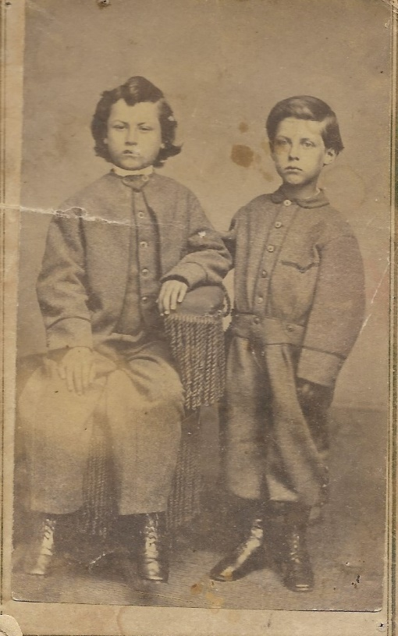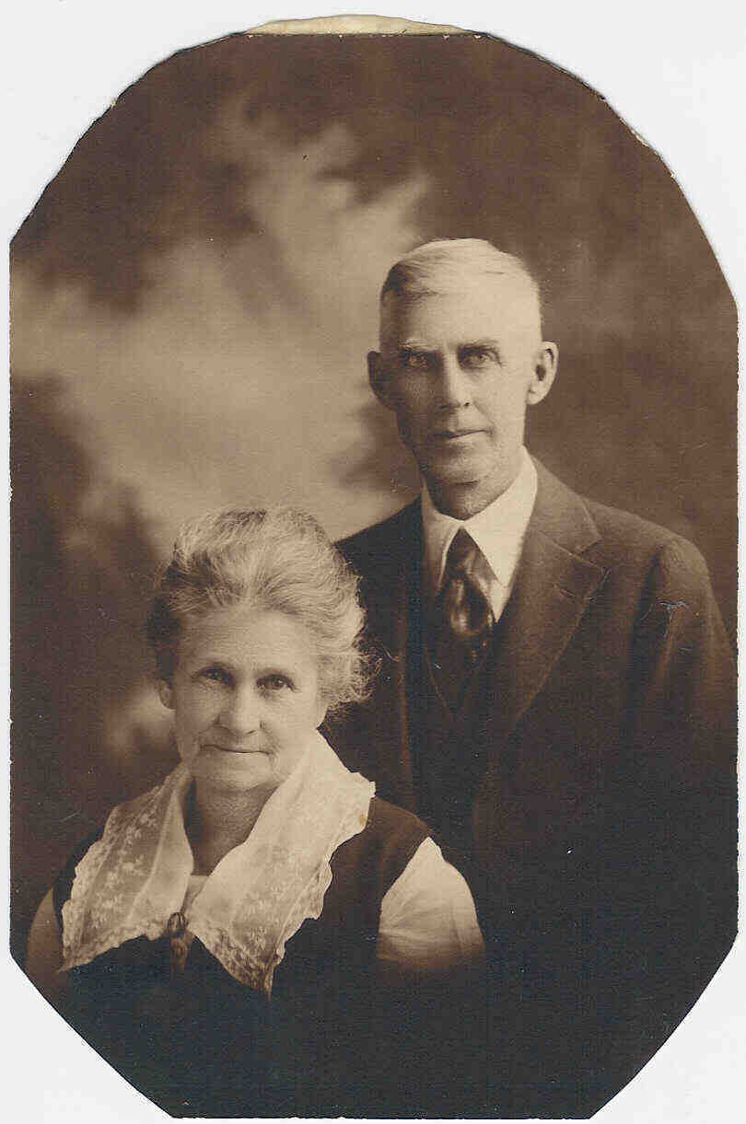
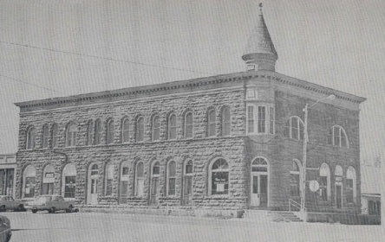

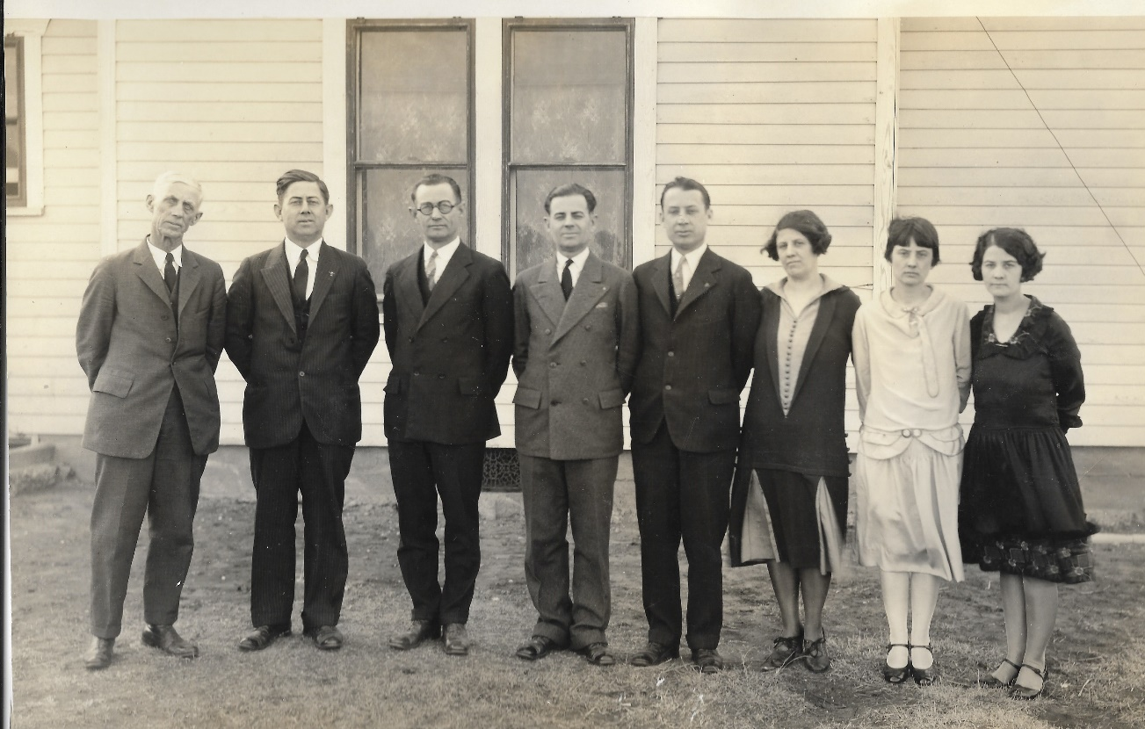

Growing up in Supply

When I was growing up in Supply both my father and mother worked in the bank. I remember having to go to the bank with my parents after supper so they could finish the day’s work. I would sleep either on the counter o on a desk curled up around a typewriter. I was always afraid of being put in the vault.
My grandfather died when I was only one, thus I never knew him. My grandparents had a large, beautiful two-story house. It had a large porch that went around three sides of the house, with four different doors into the house. There was a white fence and I remember the passionflower and trumpet vine and the honeysuckle in the yard. We also had a separate chicken yard, a little storage barn, and a potty under the trees. There was a garage where my parents kept a large touring car. I would sneak into the garage, get in the car and pretend I was driving.
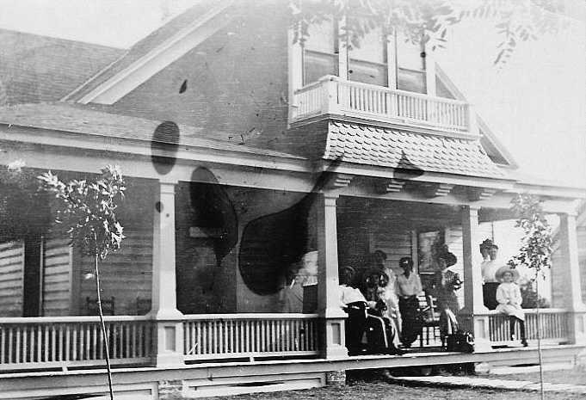
The inside of the house was beautiful and the rooms seemed large; they had pocket doors. When you came in front there was a large staircase right at the door. At the top of the stairs there was a door and a step or two going down to a small room on the front of the house. There were bedrooms on either side of the hall and at the end of the hall was a large room with a beautiful dance floor. Parties and dances were held here. Also, there was a small room off the hall that was used to serve refreshments when we entertained. I remember the Christmas tree was always in the parlor and we could not open the doors until Christmas day. I remember my grandmother had a very large woodburning stove in the kitchen. It had ovens on the side, a warming oven above the burners and a tank at the end where hot water was available. I really loved this old house and was very sad when it was blown away by a cyclone after we moved to Woodward.

After my grandfather died my grandmother moved into a smaller house closer to town and my family moved into the large house. This house was further out on Main Street where the road turns to go to Woodward. As a little girl I remember playing games on Saturday beside the bank and at Davis’ drugstore. At times I would buy all the other kids something to drink and then charge it to the bank. My daddy was not always happy with this.

The house was probably less than a mile from the river and I remember at night hearing the cattle going down to the river during the cattle drives. Also, there was an old wooden bridge not far from the house and when a car or truck went over the bridge it reminded me of thunder.

I also remember the houses where the Cunninghams, Uncle Burrel, Aunt Jo, Dr Stelcher, and where the Hursts lived. Aunt Ethel and the children would come to Bonnie’s in the summer to visit Dr. Bagby and Mary Lou (or Davis). Mrs. Bagby taught me "expression", which was how to talk and conduct yourself as a lady. The two-story schoolhouse had a tube-like fire escape. We loved to slide down it although we were in trouble if we got caught. Daddy and Dr. Stetcher would play checkers at Davis Drug Stores, Daddy would be puffing on a cigar and Dr. Stretcher would have his pipe. Dr. Stretcher is the doctor that delivered me.

There was much love in our family. I adored my brothers, nine and ten years older. Like many of us, my parents were mostly concerned with teaching me to be polite and do the correct things. My mother believed in the saying "children should be seen but not heard." So I thought about many things that were not said.

My brother Don played the trombone. At times he and Red Vaughn, whose wife was the postmistress, would start playing late at night in the town’s bandstand and my daddy would have to go down and bring him home.

I remember Mother, Don, Sam and I moved to Norman for the school year, 1926-27 so Don could go to OU. This was Sam’s senior year and he graduated from high school in Norman. He was not happy because he couldn’t graduate from Supply.

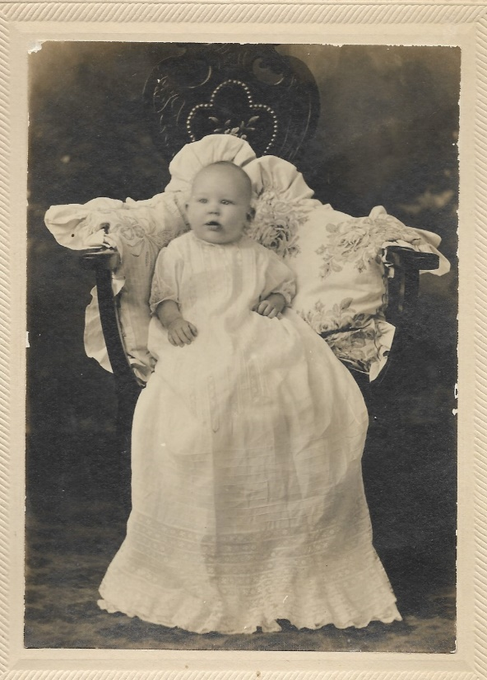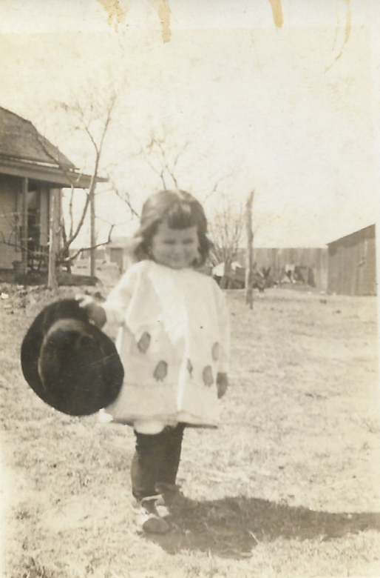

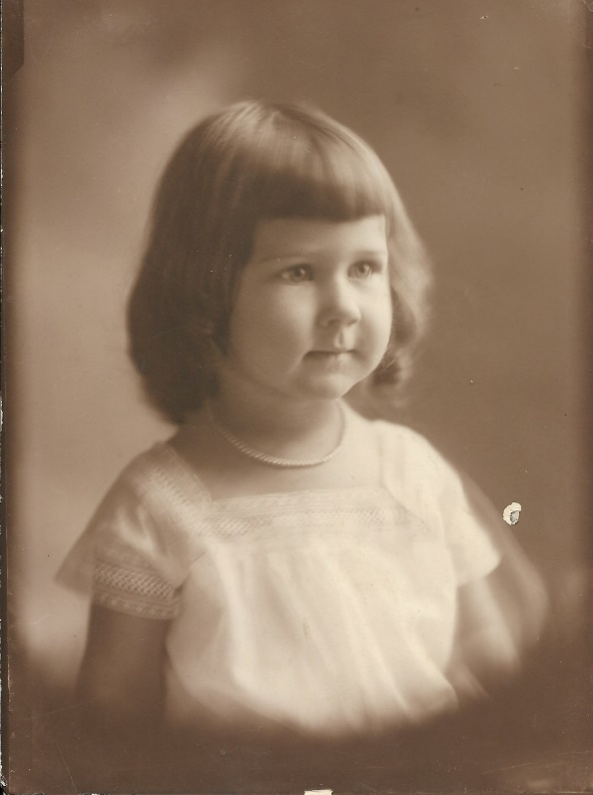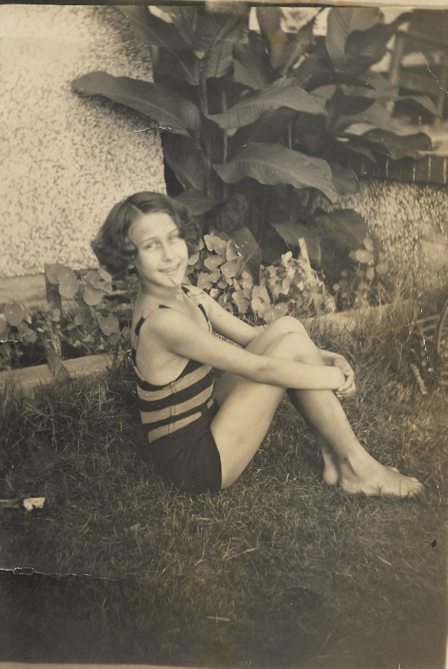

Lone Wolf

Lone Wolf We lived in Supply until 1929 when the Bank of Supply moved to Woodward in an attempt to remain solvent during the depression. It was located on the northwest corner of Ninth and Main. J. O. Selman, who was one of the ten largest landowners in Oklahoma, became president, Uncle Burrel, vice president, and daddy was vice-president and cashier. In 1931 the bank had to merge with the Bank of Woodward and that was the end of banking in my family.
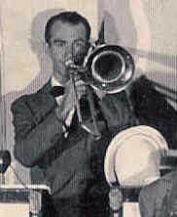
Don was attending school at Oklahoma A&M when Don's band failed and he had to drop out of school his sophomore year. He went to Dallas and was a member of the house band for radio station WFAA during the day and would play at dances during the evening. He traveled quite a bit, went as far as Arizona. He ended up in Texarkana around 1940 and decided to go back to A&M to finish his degree and went on to get his masters. He met Lemmah Anderson in 1943 while they were teaching at Leverett’s Chapel in Texas. Their classrooms were across the hall from each other. They were married on August 17, 1946. Don was the academic of the family and received his Ph.D. in counseling in 1954.
Jon must take after Don, for he was always the clown of the family. The kids would love it when Don would blow up his muscle. Don and Lemmah moved to the valley in south Texas and one year Ed gave up a trip to Colorado so he could spend the summer with them. Don died in 1964 from complications of an operation. Everyone fell in love with Lemmah and I believe all of the family have thought that she was just part of the Dorr clan even after Don passed away.
I remember daddy taught me how to write checks. After the bank failed, we moved to Lone Wolf. Sam had married Ellen who was from Lone Wolf. Her father owned a grocery store there. Daddy had trouble with the banking commission and with no job, it seemed like we always needed money; rent always due, washer and other things. We ate quite a bit of corn bread and much pork chops. I went to Oklahoma City to live with Uncle Burrel and Aunt Jo, and went to Classen High School my junior year.
I fell in love with boy name Woodie in high school and just missed getting to be football queen my senior year. I remember the last Christmas with Bonnie at our house. I wore a beautiful red formal taffeta dress. I remember Uncle Knight and Bonnie both were at my graduation. The next fall I enrolled in postgraduate courses at the high school. I believe I took typing and algebra. Aunt Pete helped me and I enrolled at Southwestern State College in Weatherford.
There was so much turmoil in our family at this time. Daddy had begun to drink; he was a broken man when we lost the bank. Daddy, Mother and I went to Supply for part of the summer. Daddy got a job with the state highway commission in Perry. I drove back to Lone Wolf with only HiLo, my dog. This was my first trip alone.
When I graduated from high school, Bonnie paid for me to visit Woodward, where I still had many friends. Bonnie planned to come to Woodward from Supply on the train, but when she got off the train she fell and broke her leg. This resulted in a blood clot and she died the next day.
In the fall Mother and I moved to Stillwater and I enrolled in school at Oklahoma A & M for my second year of college. Daddy would sleep on a cot in a closet at the highway department during the week and come to Stillwater on the weekends. We first had a duplex on 4th street.

Church Life as Youth

We didn’t go to church very often when I was a child. My idea of God was vague. However, I was taught to kneel at bedtime and say “Now I lay me down to sleep, I pray the Lord my soul will keep. If I should die before I awake, I pray the Lord my soul to take.”
My father was a divorced Southern Baptist. How well he knew the Lord or the church never was discussed. My mother’s family was Catholic and she had attended college in Missouri at a Catholic convent school. Mother of course was denied the sacraments of her church because she had married a divorced man. I realize now that must have hurt her deeply. There was not a Catholic Church in the little town of Supply and she was too much Catholic to attend any other church and my father loved her too much to make an issue of it. So, he didn’t go either, thus I did not have much of a church life as a young girl.
There was one true Catholic family in this little town of Supply, the Messells. They drove every Sunday (weather permitting) to the larger nearby town of Woodward to go to church. We would drive there too occasionally. I loved to go. It was a small wooden church, rather sparse looking except for the pictures down each side. Most of all that drew my attention were the little beautiful sculptures of Jesus as a baby with his mother. They looked so beautiful and happy. I wondered if he ever got into trouble and got spanked.
Nothing of the service was ever explained to me, but I felt it was special and beautiful when certain parts of the service called for standing, sitting, or kneeling. I wanted so much to do what my mother and the others were doing, but mother would whisper “just sit still and watch.” But even then I wanted to understand what they were doing and why. I would look around at the beautiful little statues and lovely stained-glass windows and wonder where God was. I wanted so much to see God. I thought that maybe He is busy answering my prayers. My mother never had time to explain chapel procedures. But I liked it and it was special to go whenever we did.
So growing up in the church was not really a part of my life. Even later when we moved to Woodward, church service was only an occasional thing. I don’t remember ever going to the Catholic Church together again with them until Sam and I were grown and we were living in Oklahoma City.
I was so locked into this loyalty problem that I rarely attended church unless specifically invited, even in college. Occasionally I would go with my mother to the little Catholic Church in Stillwater. This is ridiculous, but in college whenever it was necessary to fill in a questionnaire that asked for church preference, I wrote “Catholic or Baptist” which would have been a good laugh! Although I cannot remember any specific religious training as a child, I undoubtedly had some instruction. I always knew there was God and Jesus and wasn’t sure about the Holy Spirit. I did not belong to a church until I was married and had two small sons.
As Don and Sam became independent church was not a part of their lives, although they had been confirmed in the church. As Sam and I shared after Ellen’s death, he so wanted to have his relationship with God and open his heart and mind to Him, but Sam soon died. But I know the Lord was with him. And Sam was His.

Dorr’s Family
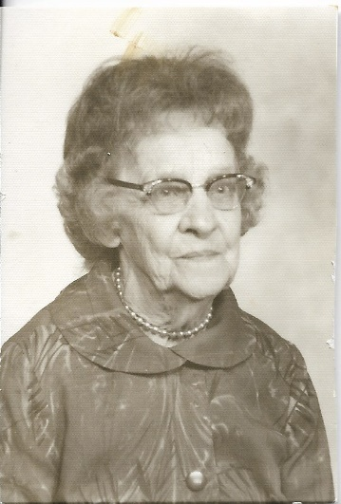
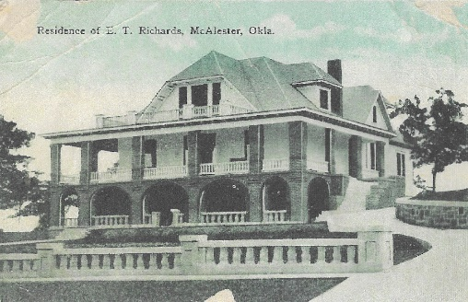
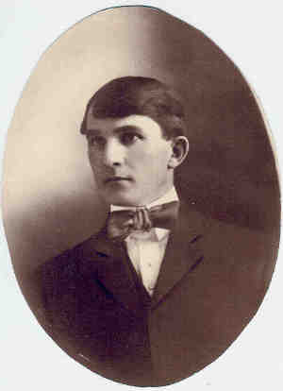
Mother Dorr, Laura Estelle, was born in 1882 in Macon, Tennessee; she was the oldest daughter of ten children. In 1986 a hardbound book was published on the Boswell family and has much more information on the family. Mother Dorr met Ernest while on a visit to her Aunt Lucy Trotter in Mississippi. She and her sister Lettie were married in a double ceremony in 1907. They moved to McAlester, Oklahoma where Albert Ernest owned a barbershop. Dorr had a brother ten years older than he, Ernest B., and a sister six years older, Dorothy. Six months before Dorr was born his father was killed in an automobile accident and Mrs. Dorr returned to Macon, Tennessee for his birth. Three months after Dorr was born, she moved back to McAlester and bought a nineteen-room house where she took in boarders. The house was across the street from the fire station and Dorr became their mascot. When Dorr was only a few years old he fell out of a second story window and landed on his head on the sidewalk. It was a miracle that he lived, but he had a permanent scar on his forehead. He worked as a soda jerk during high school and also in college. He graduated from McAlester High School in 1936 and he and Mrs. Dorr moved to Stillwater where she again ran a boarding house. This enabled Dorr to go to college.
One of Mother Dorr’s sisters, Annie, also lived in McAlester where her husband had a candy business. Dorr’s older brother B. had three children, Albert, Sandra and Kay. His sister Dorothy also had three - Rae Donna, Winston and Leon. Rae Donna lived with us on NE 27th during her senior year in high school so she could attend school in the city.
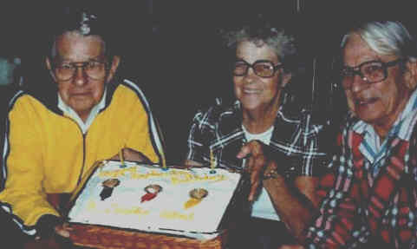
B., Dorothy, and Al Dorr on 1987?

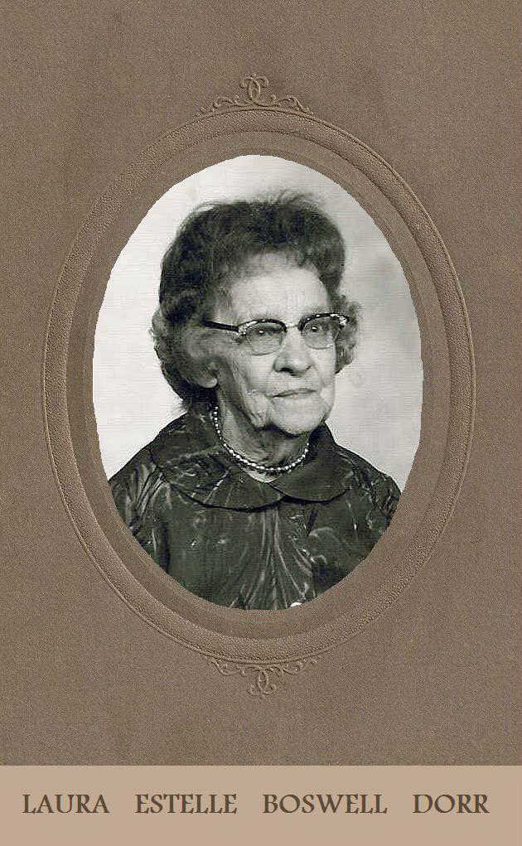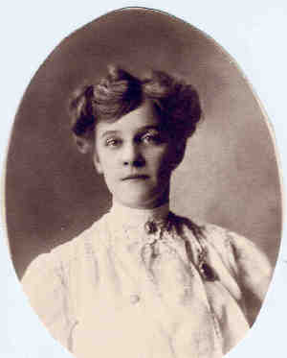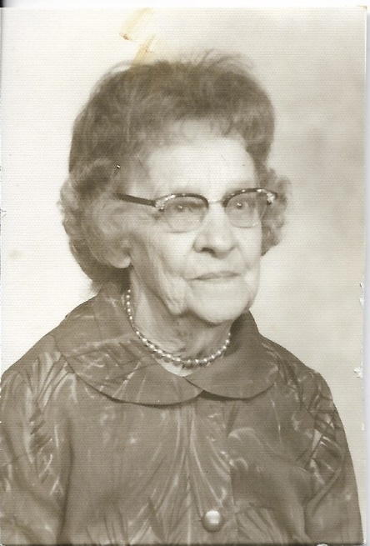

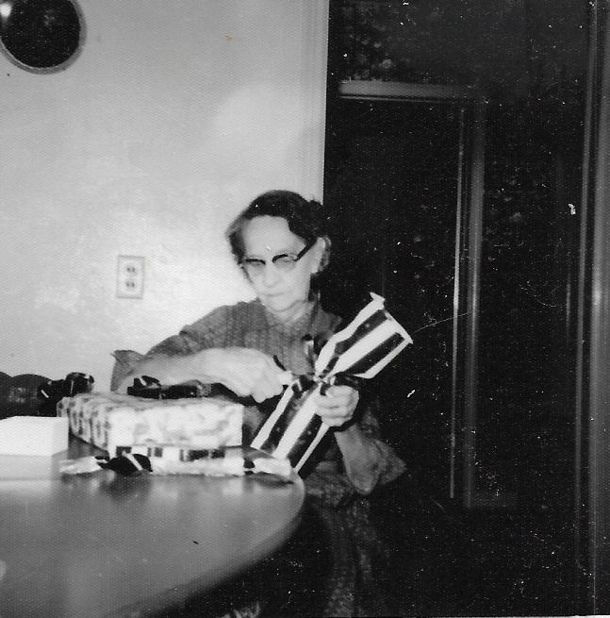

Early Years with Dorr

Dorr originally enrolled in electrical engineering but had to drop out his second semester because he was failing twelve hours. He switched to mechanical engineering and made the dean’s honor roll.
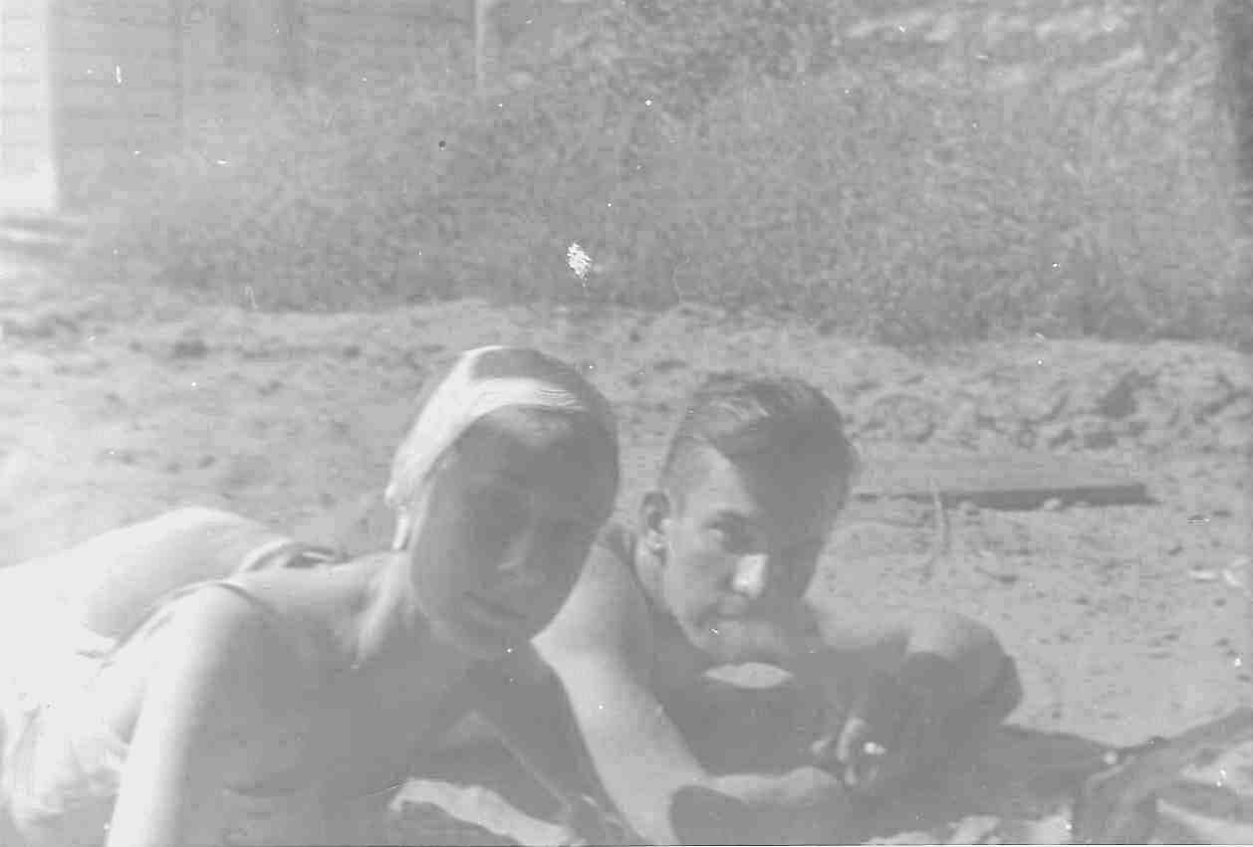
I met Dorr in December 1938 at an Acacia Christmas party at Fiscus Hall. This is where Pat has his museum today. I was with Bus Walker, his best friend. We also went to Tulsa to hear Gene Krupa, the drummer, that night. That summer Mother and I moved almost on campus to an apartment in a large house across from the Acacia house which was next to the Thorton Smith store and the restaurant. Dorr would come over and we would sit in the swing on the front porch and talk. Dorr was the social chairman and later became vice president and president. He also was president of the Inter-fraternity Council.
Dorr and I started dating some this summer. We went swimming on our first date at Yost Lake, north of Stillwater. On one of our first dates, I had the split-second sense that this might be the person I would marry. I said no. By fall, Dorr and I were dating quite a bit, but not steady. He asked me to wear his fraternity pin, but I was not ready at that time. Since he had just flunked out of school, the semester before I told him I would wear it only if he made the dean’s honor roll. The next semester he made the dean’s honor roll and I secretly wore his fraternity pin. My parents did not want me to get involved; thus, I had to put the pin on after I left the house.

Mother and I moved again to the little duplex across from Fiscus Hall, (505 College) cater-cornered from the Campus Theater where I worked. During this time, I pledged Alpha Delta Pi sorority, but kept delaying the initiation because it was $75, which I couldn’t seem manage on top of monthly dues. I lived at home with my mother. Daddy stayed at Perry during the week. He slept on a cot in a storage room. In February Dorr gave me my diamond which upset my parents. At mid-term exams we (Mother Dorr, Dorr and I) were gassed at the apartment at night. We all recovered.

Marriage
Dorr and I decided to get married on Ju1y 1,1940. Convinced the folks (Mother really on May 31 at 11 PM). What a day! His mother, however, welcomed and loved me warmly when we were married. On Saturday, Daddy came in from Perry. Don and Uncle Knight were living with us. Sam and Ellen were living in Stillwater then too. I bought a dress, gown and robe, ordered a cake, had the dress altered and my hair fixed, besides cleaning the house.
We were married at 9:00 PM at the house on Hester where we had moved after Uncle Knight came to stay. The wedding announcement has 1621 College as the address. Those attending were Mother, Daddy, Sam and Ellen, Uncle Knight, Mr. and Mrs. Messell, Bill and Mrs. Newell, Mrs. Dorr, Don, B. and Thirza, who came on a bus. Don played wedding music for us then he broke into swing music. I was so mad at him and tickled at the same time. The Methodist minister that married us was blind and I always wondered what he was thinking as Don played.
We drove B’s car to Oklahoma City and we didn’t arrive at the Biltmore until 2:00 AM. For a number of years, we would go back to the Biltmore and stay in the same room (Room #1707) on our anniversary. We stopped in Guthrie and had hamburgers. We had until Monday noon when we had to be back for Dorr to go to work at the Midwest Creamery as the fountain manager for 25&cent; an hour. We had $100 in the bank and we both still had three semesters left. Dorr worked every Sunday, which didn’t help draw us into a church
We lived in a one-room garage apartment the first month and Mrs. Dorr moved to a house closer to the campus for the school year and again kept Brad and three other boys. After a month on our own we decided to live there too with Mother Dorr until Dorr graduated at mid-term. This house was located at 308 West Elm. (Note: It still exists in 2003.) After we were married, Mother moved to Perry to be with Daddy. Uncle Knight went back to an old soldier’s home in Kansas City for a while. After the school year Mother Dorr moved to Macon, Tennessee to be with her brother Dewitt. She taught in a country school, but every summer she would come to visit us. His mother became my best friend. Al’s mother was an active member of the Methodist church.

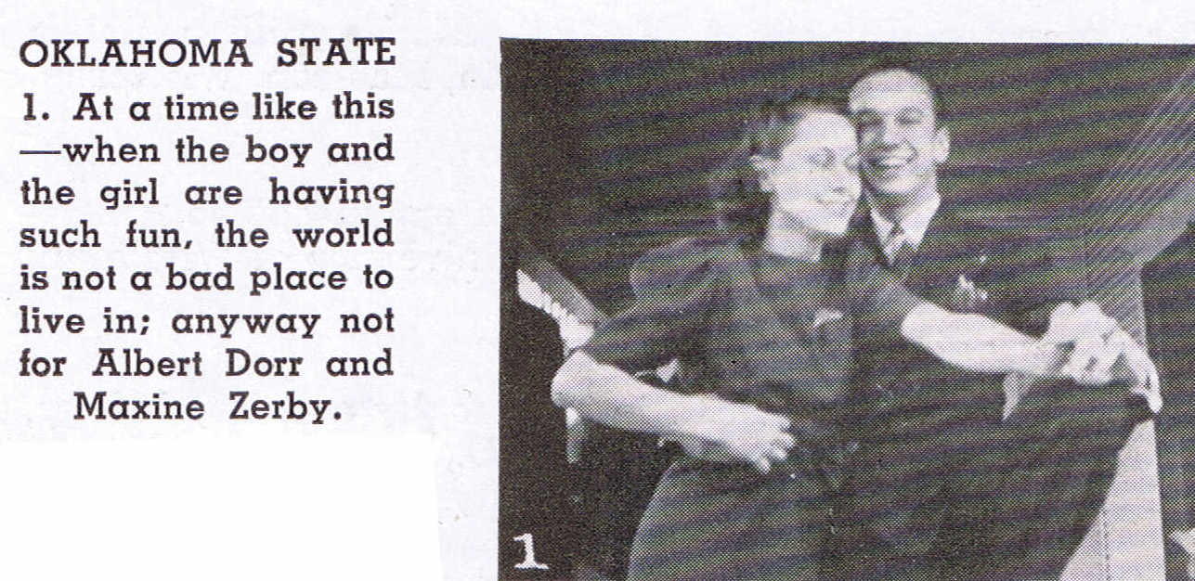

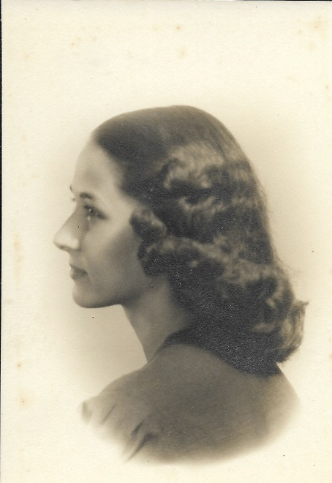

Ed’s Cerebral Palsy
It was Valentine’s Day at about 1:30 that I began having pains with Ed. They took me to the little Catholic hospital. Our young doctor and his wife were expecting a baby the same time as we were. And that was correct timing. When I went into labor, my doctor was with his wife at an Oklahoma City hospital. Their baby died at birth. The nurses at the small Catholic hospital (and only hospital) in Stillwater drugged me to delay labor until the doctor could get back. When he did come many hours later, he was so exhausted and despondent that he collapsed in the delivery room. Thank you, Lord. There happened to be an old doctor doing something in the basement of the hospital. He hurriedly came and finished delivering our baby by brute force causing brain damage resulting in cerebral palsy. He realized the baby should have been taken by caesarian section since the baby was too large for me, but it was too late by then. We were both baptized in the delivery room since there was a good chance one or both of us would not survive. Now I didn’t know how to pray except to cry “Help” and this I did. Didn’t know the God to whom to pray, but thanks to Him he knew me.
Somehow in my inner me I knew our baby did not have a chance to live unless God intervened. My understanding of this as well as the understanding of his injury was small, but somehow, I did understand that he needed to be in God’s care. Prayer and interceding entered my life. God met my challenge and taught me to trust Him through my little son. I have to admit there was very little else in my life I turned over to Him, but I had learned what He could do.
I learned more about prayer listening to the Mother Superior as she would take our son out of the incubator and take him into the room next to mine and pray over him and move his little arms and legs. I wish I could have heard it all.
Our son did survive and was a beautiful baby. His progress was very slow, but always forward. We did not realize that he had cerebral palsy until he was two-year-old. We were overjoyed as we realized what intelligence he had. He learned everything quickly, but his movements were slow and difficult and his speech was not very intelligible. Dorr went back to work. My mother and father were distraught. I went to mothers until Ed had his six-week checkup. Dorr came on weekends. He finished training and we moved to Oklahoma City and had our “very own” little house. We could not find a doctor that really knew anything about what to do for a cerebral palsied child.
Also, I had been advised by three different doctors not to have any more children. So, when I found out a year later that I was pregnant, we were scared. The doctor that confirmed my pregnancy advised me to have an abortion. He said I might not have trouble in delivery, but felt I would need all my time and energy for our injured child. I realized abortion couldn’t be the way. So once more I had to call on God for help.
We made a search for the best obstetrician in Oklahoma City and talked at length with him. He looked me in the eye and told me not to worry, that no matter what would happen he could take care of it. It seemed crazy, but I looked back at him and said, “I believe you.” After a few months I had a fast and perfect delivery. Praise to God. We had another beautiful little son, Dana Michael on September 23, 1943, who was as healthy as could be and has been a joy, help and strength to us.
We had learned there were only three specialists in the U.S. who had training in cerebral palsy. But they were on the east or west coasts. When Eddie Max was about two, we heard that one of the specialists would be in Wichita, so I hurriedly secured an appointment and was so hopeful.
After examining our son the specialist said, “If you want other children, which undoubtedly you do since you have this baby, I would advise you to put your injured son in an institution since he will never be anywhere near normal.” I was crushed and very angry too. I believe I must have walked out of that office muttering “God, let’s show him.” But there wasn’t much we could do. Remember this was fifty-four years ago, so again I had to cry to God for help.

Ed’s Cerebral Palsy
It was Valentine’s Day at about 1:30 that I began having pains with Ed. They took me to the little Catholic hospital. Our young doctor and his wife were expecting a baby the same time as we were. And that was correct timing. When I went into labor, my doctor was with his wife at an Oklahoma City hospital. Their baby died at birth. The nurses at the small Catholic hospital (and only hospital) in Stillwater drugged me to delay labor until the doctor could get back. When he did come many hours later, he was so exhausted and despondent that he collapsed in the delivery room. Thank you, Lord. There happened to be an old doctor doing something in the basement of the hospital. He hurriedly came and finished delivering our baby by brute force causing brain damage resulting in cerebral palsy. He realized the baby should have been taken by caesarian section since the baby was too large for me, but it was too late by then. We were both baptized in the delivery room since there was a good chance one or both of us would not survive. Now I didn’t know how to pray except to cry “Help” and this I did. Didn’t know the God to whom to pray, but thanks to Him he knew me.
Somehow in my inner me I knew our baby did not have a chance to live unless God intervened. My understanding of this as well as the understanding of his injury was small, but somehow I did understand that he needed to be in God’s care. Prayer and interceding entered my life. God met my challenge and taught me to trust Him through my little son. I have to admit there was very little else in my life I turned over to Him, but I had learned what He could do.
I learned more about prayer listening to the Mother Superior as she would take our son out of the incubator and take him into the room next to mine and pray over him and move his little arms and legs. I wish I could have heard it all.
Our son did survive and was a beautiful baby. His progress was very slow, but always forward. We did not realize that he had cerebral palsy until he was two-year-old. We were overjoyed as we realized what intelligence he had. He learned everything quickly, but his movements were slow and difficult and his speech was not very intelligible. Dorr went back to work. My mother and father were distraught. I went to mothers until Ed had his six-week checkup. Dorr came on weekends. He finished training and we moved to Oklahoma City and had our “very own” little house. We could not find a doctor that really knew anything about what to do for a cerebral palsied child.
Also, I had been advised by three different doctors not to have any more children. So, when I found out a year later that I was pregnant, we were scared. The doctor that confirmed my pregnancy advised me to have an abortion. He said I might not have trouble in delivery, but felt I would need all my time and energy for our injured child. I realized abortion couldn’t be the way. So once more I had to call on God for help.
We made a search for the best obstetrician in Oklahoma City and talked at length with him. He looked me in the eye and told me not to worry, that no matter what would happen he could take care of it. It seemed crazy, but I looked back at him and said, “I believe you.” After a few months I had a fast and perfect delivery. Praise to God. We had another beautiful little son, Dana Michael on September 23, 1943, who was as healthy as could be and has been a joy, help and strength to us.
We had learned there were only three specialists in the U.S. who had training in cerebral palsy. But they were on the east or west coasts. When Eddie Max was about two, we heard that one of the specialists would be in Wichita, so I hurriedly secured an appointment and was so hopeful.
After examining our son the specialist said, “If you want other children, which undoubtedly you do since you have this baby, I would advise you to put your injured son in an institution since he will never be anywhere near normal.” I was crushed and very angry too. I believe I must have walked out of that office muttering “God, let’s show him.” But there wasn’t much we could do. Remember this was fifty-four years ago, so again I had to cry to God for help.

Perry During the War

In 1944 he enlisted in the Navy and went through officer candidate school in Hollywood Beach, Florida where he received his commission as an ensign. The ship stopped at New Orleans for a week and I went down on the bus to see him. I could not locate Dorr the first night and New Orleans was different from anything I had seen before. (Below is a postcard mom sent) The ship then went through the Panama Canal and up the West Coast to San Francisco, where he attended navigation school. I went up to San Francisco on a train to see him for a week. He went on to Seattle for additional training. This time I took the train to Seattle and spent two more weeks with him. Dorr always had a 35-mm camera and he made extra money in school and after graduating by taking pictures. While in Seattle he bought photographic equipment and set it up in his stateroom. He was promoted to Lieutenant JG, and was the navigator of the LST. He traveled in the Pacific on an LST 817 for two years. His only major encounter was at Okinawa. He also saw Iwo Jima and both atom bomb devastations.
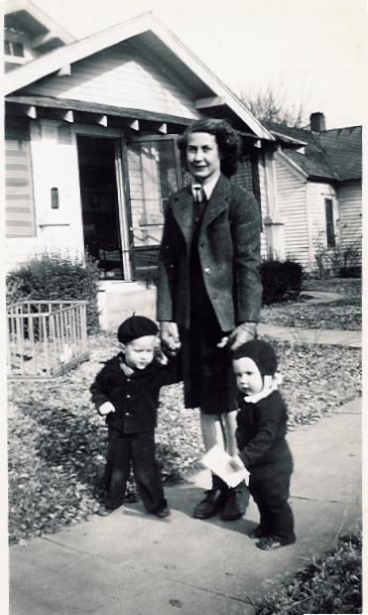
While Dorr was in the Navy the boys and I went to live with my parents in Perry until Dorr came back. A couple had volunteered to help us move to Perry with a trailer they had. We got about five miles outside of Wichita when the tire went flat on the trailer. We unloaded all the furniture on the side of the highway. It was a hot August day and we had both boys with us. A cattle truck came by and offered to take us all the way to Perry. So, they loaded all of our things in the back, which was not very clean. Dorr, the boys, the driver and I all rode in the cab. It was so hot but we were so glad just to get to Perry.
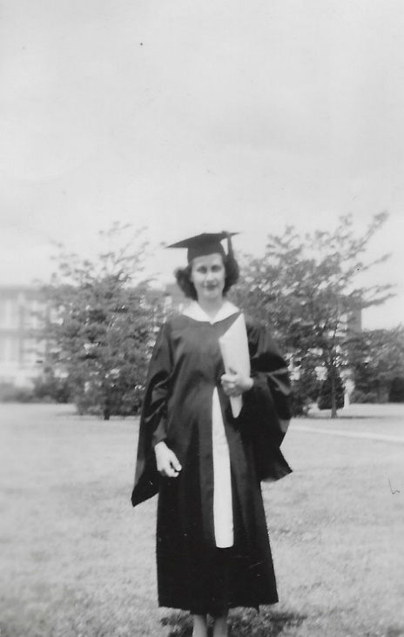
During this time, I was able to complete the seven hours I needed to graduate at A&M and would go in for criticism, thus earning my degree. (I even got a loud “Mommie!” from Mike as I walked across the stage to get my degree.) Daddy had been with the state highway department since the time the bank failed in Woodward. He would continue to work for the highway department until he retired in 1957.

I do not believe Daddy ever had a car in Perry. He always walked to and from work. I would take Eddie Max and Mike down to the town square where they enjoyed playing on the little bandstand. I had a big baby buggy and I would put one at one end and the other at the other end. We went to the library, the drug store and Linderman’s grocery store every pretty day. My parents still had HiLo, my dog I had in Lone Wolf. The doctors had told me that if I got Ed a tricycle it would help his coordination development. During the war it was impossible to buy anything like that, but Real Pitts, Dorr’s boss at the creamery heard about this. He found a tricycle that needed work so we took it to a machine shop in Stillwater. The man had to use parts from another tricycle, but Ed ended up with it. This was good for Ed since he could not walk, but he could really move on that little tricycle.
Mike would stand on the back and they would go up and down the sidewalk. Later after we had moved to Oklahoma City and they were old enough, the boys would ride the train by themselves to Perry to see their “Mimi” and “Nini.” We even made up a song about riding the train to Perry.

By this time my husband was home safe and in good shape. Believe me, I had much practice in prayer by now.

Naturally Dorr took pictures all during the war. Since he was an officer, he could not sell the pictures to the men; thus, he gave them away. While they were in port, he would rig up a dark room and develop and print pictures for the men. Whenever they were with an aircraft carrier, he would bum paper and chemicals since they always had more supplies. While in the Navy he took orders for books of fifty pictures for ten dollars. For the first few weeks after he returned in 1946, he practically lived in my parents’ cellar where he had set up a dark room. I believe he made about five hundred dollars and spent it on a new professional camera, like the ones you see the photographers using in the old forties’ movies. Dorr was always looking for ways to make money.

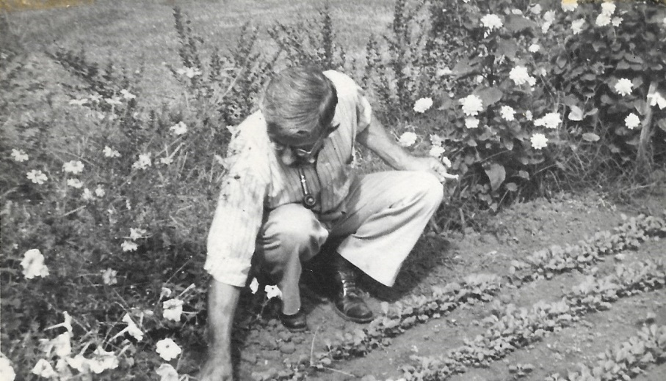  Mother and Daddy always enjoyed working in the yard; Daddy had his garden and Mother her flowers.  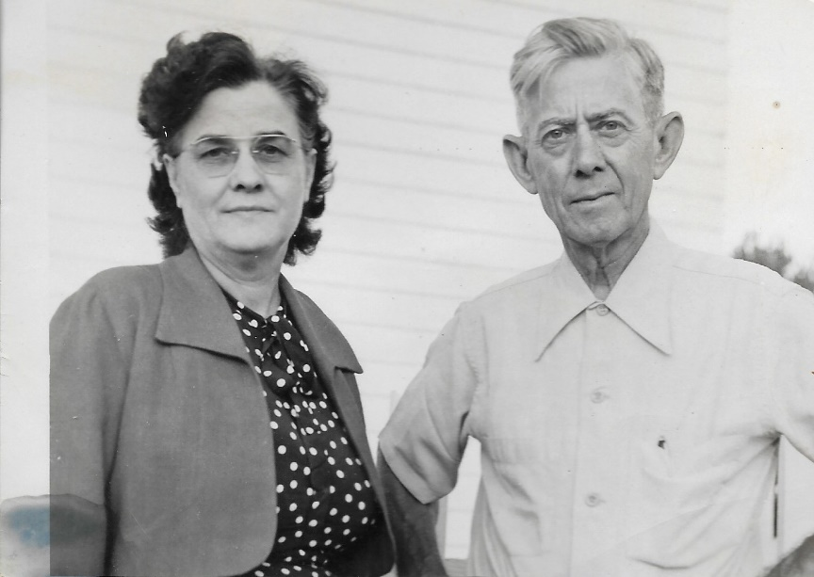 | 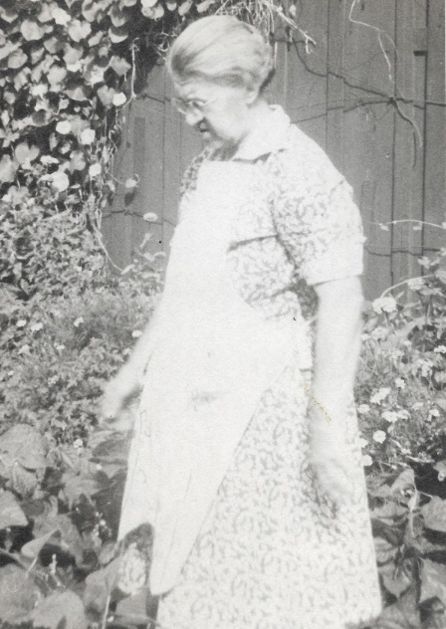
Percy with his sister “Aunt Pete”

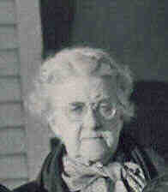 | 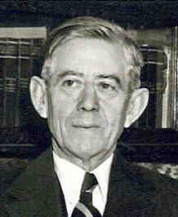

 | 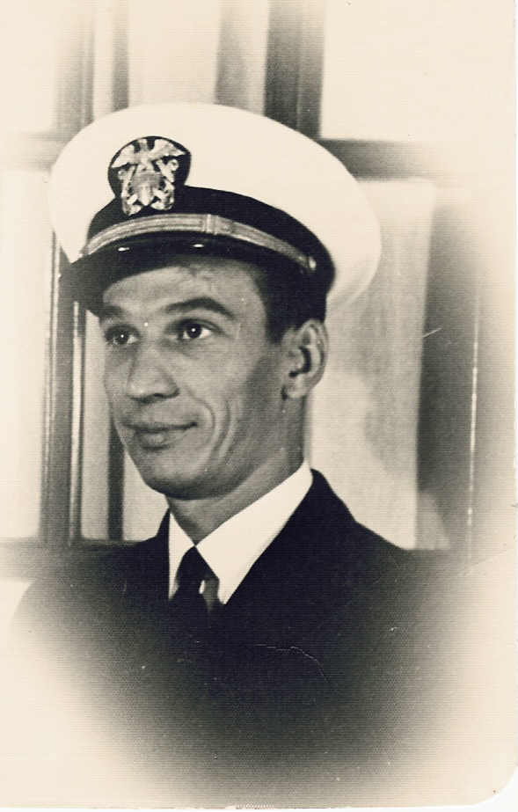 | 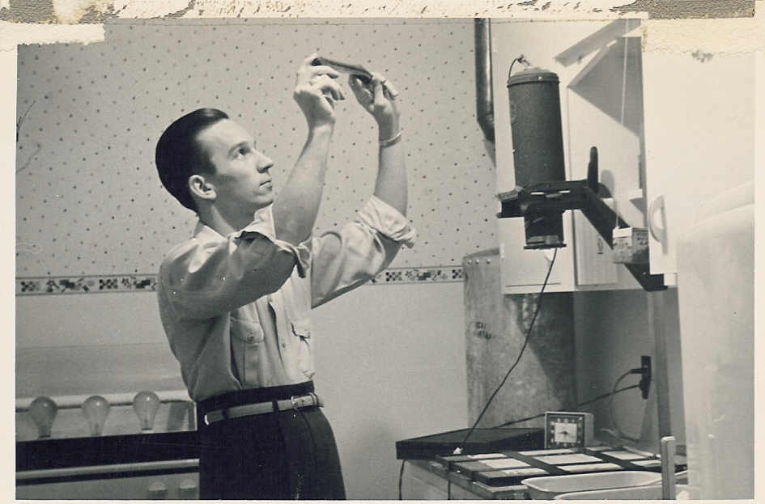
 | 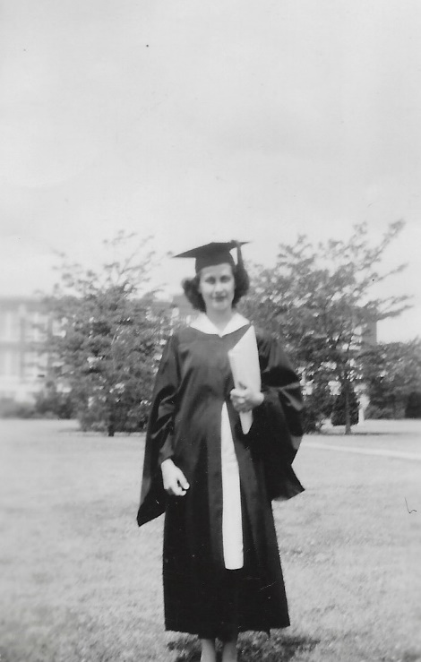

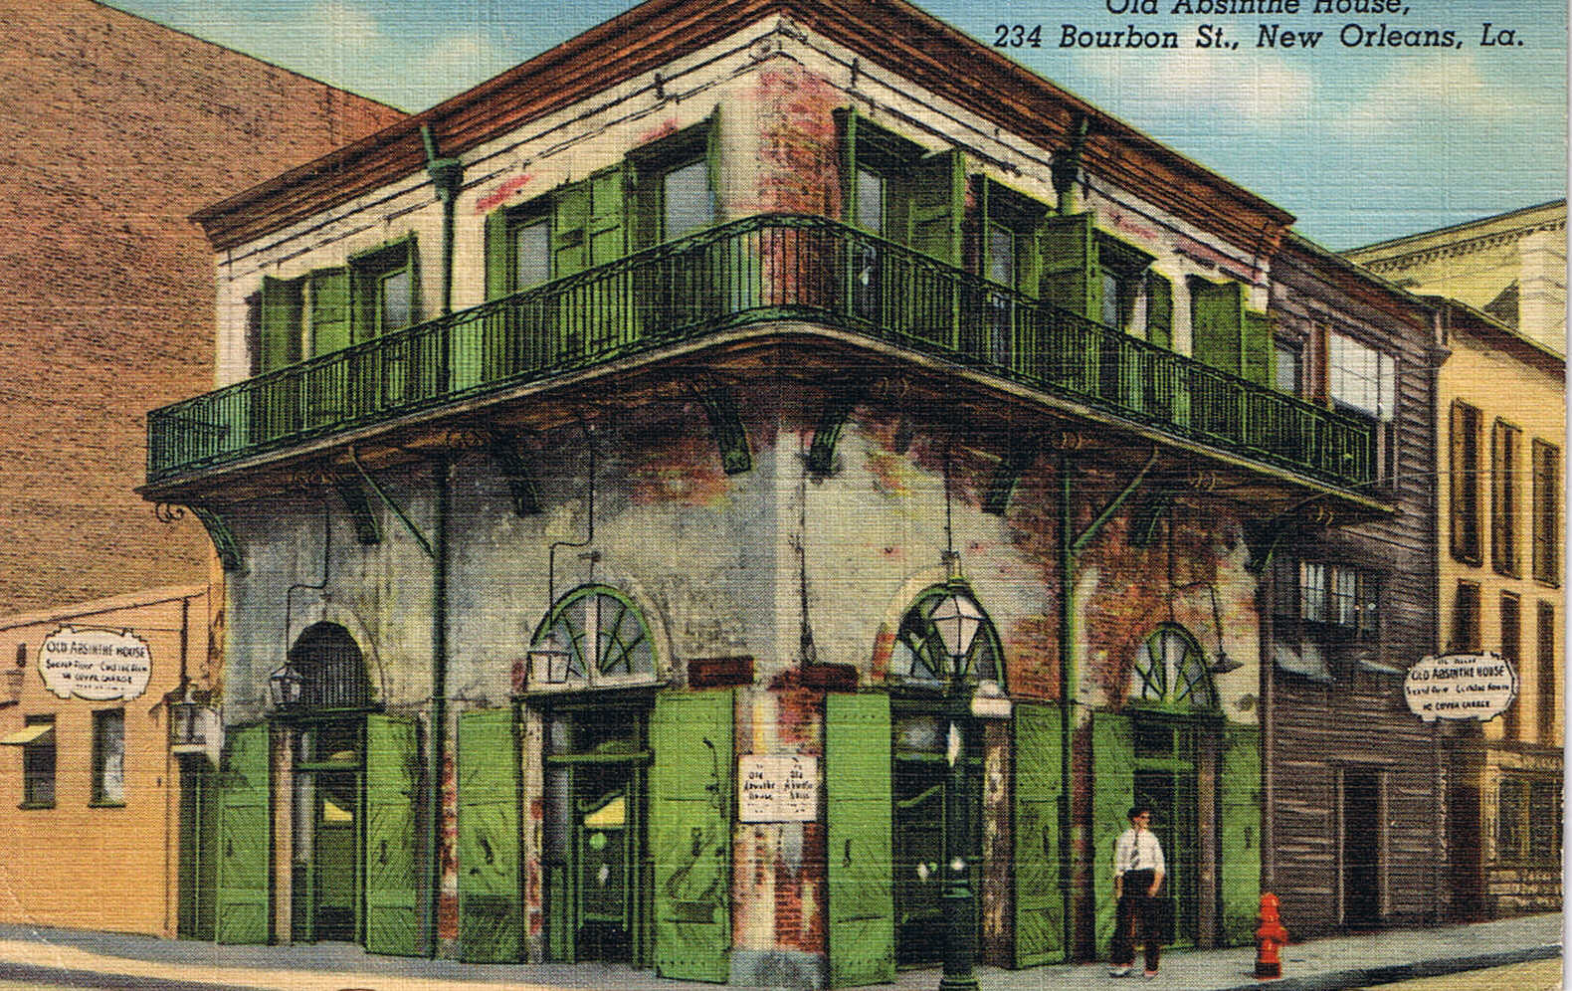

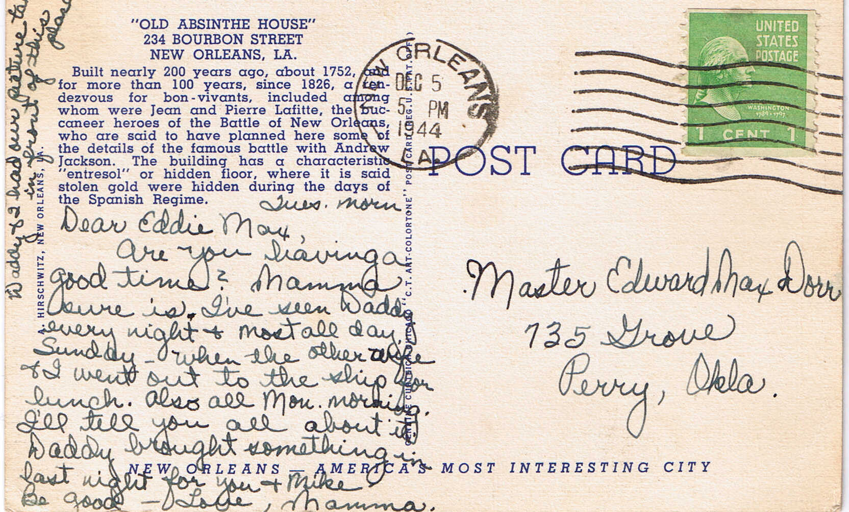

Early Years in OKC

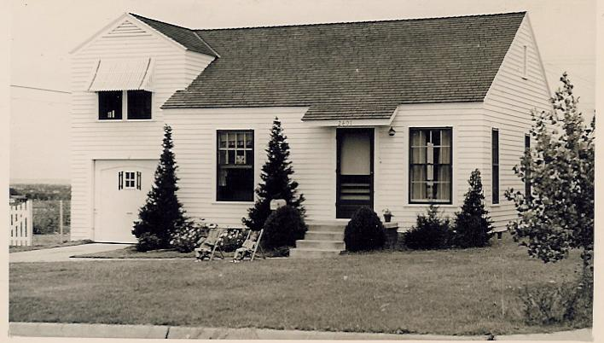
After Dorr completed all the books of pictures, he took a job with C. H. Guernsey & Co., a local engineering firm. Dorr rented a room and I would go down to Oklahoma City on the weekends to look for a house. He was supposed to be designing sewage plants which he did not know about and he left after several months and took a job with OG&E. We bought a little two-bedroom home in a new residential section called North Creston Hills. We joined the little neighborhood Presbyterian Church. My first church - I was delighted. We had a church! And I loved it. We didn’t always go to Sunday School although we took the boys. The houses were small two-bedroom homes, but the neighborhood was great for raising kids. Next door to us were Red and Esther Ellis who had a son, also named Mike. Bert and Helenita Wagner lived across the street with their children, Jay and Patty. All the kids loved to play with Bert.
When it snowed, Bert would pull the kids on a large sled with his car. He later became the office manager for Dorr at Comfort, Inc. There were a number of other kids in the neighborhood. Back then we did not worry about things like we do now and the kids would stay out at night playing games like run sheep run and hide and seek. We had a television the day that the first station came on the air. This was the only television in the neighborhood and in the evening, there would be a number of kids lined up on the steps going down to the kids’ room watching TV. Also, we had the first room air conditioner in the neighborhood. It came from an army surplus sale.
A year later we had another little son, Pat B., a little baby this time. We just knew that this was going to be our little girl, but Patricia became Pat. I was baptized again, in consciousness this time, along with my little sons. This was a noisy time. It was also good for our injured son. Eddie Max did not talk or walk until he was four. He could only walk a short distance without falling so we would put a football helmet on him for protection and let him go. We all learned from him.
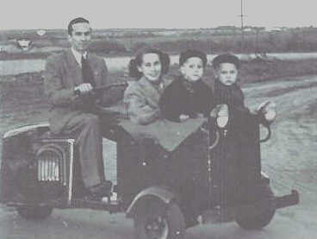
Buying a car after the war was almost an impossibility. We had sold our other car when Dorr went into the service in case I would need the money. Dorr had bought a motor scooter with a large box in front where I would get in with Ed and Mike. He rode to work with a friend who lived a block from us. Our first car was a little Austin Healey. When Pat was born, he made so many trips down NE 23rd to the hospital and then back to check on the boys. This car stood out and he was once stopped by the police, who thought he must be running booze.
I took Ed to the Crippled Children’s Hospital twice a week for thirty minutes of physical therapy and thirty minutes of speech therapy. I would put Ed in the stroller, carry Pat (the baby), and Mike would hold on to the diaper bag. We would walk five long blocks to catch a city bus. Then we would have to transfer once or walk two long blocks to the hospital. While they were working with Ed, I would feed Pat while Mike would look at books or color. Thank goodness in bad weather a neighbor offered to care for Mike and Pat.
By the way, we even had a fourth and fifth son over the next few years. Jon Real arrived. He weighed 10½ pounds and he took 10 ½ months to get here. He turned out to be our character. The Lord was toughening me up for battle. Our last son, Kent Anthony, arrived 2½ years later; unusually beautiful; the doctor said perfect. We were really blessed that morning. The two hours Dorr and I spent together just before Kent was born was one of the most precious times my husband and I ever shared together, and the closest the two of us have knowingly shared with the Lord.
I had thought I wanted to be an art teacher, but I knew now I was needed at home. I was happy having our children; I loved and enjoyed them. I wanted so much to be a good wife and mother. I worked so hard at it. When things didn’t go as I thought they should I was sure it was a terrible mistake. So, I spent a lot of time and energy fighting my circumstances. I loved our little church where we were members. It was such a warm, caring church, where each of us knew one another and really wanted to share each other’s problems and joys. We recognized God’s grace in our lives, but we were missing the relationship with Him. In fact, I do not believe I had known this was possible. Anyway, we were missing it and sad to say going to church each Sunday wasn’t helping it. Now I believe the Lord cares more about relationships than almost anything; first with Him, and then with one another. Prayer back then had been a hurried call for help. In-between times I said thank you when I remembered. We tried so hard to stay on top of everything, not knowing it is impossible and certainly exhausting. We thought that if we worked hard and tried to show God we were good guys, someday we could just relax and not have any big problems. We just did not understand the life or the Gospel.
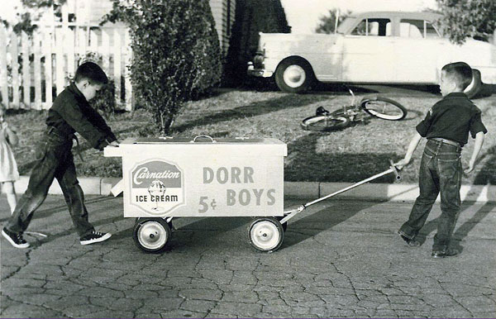
My husband was a very ambitious, quick thinking, energetic person. Since he was so poor as a child and was starting out with nothing, he wanted very much to be a success. And success to him then meant money, a business of his own, a nice house, at least two bathrooms, vacations, etc. Besides his regular job as an engineer, he always had two or three sideline businesses going. He was even an elder in the church. It was hard for him, even though he loved the boys, to understand how to be a father, since he never had one. He did not understand that besides being a material provider, that in God’s order, he, my husband, was to be the authority and spiritual teacher to his family. I guess I didn’t understand this either. But then we really didn’t have Christ as the head and center of our home either, did we? Anyway, the boys were sort of dumped into my lap, my responsibility. I had no choice. I believe now, sincerely, that this is the reason for so many problems in our families; that we are not following God’s rule of authority in our homes. Christ as head, then the father, then the wife and mother. I believe we as woman can help to keep this order. We must learn to listen closely because I believe God speaks to us through our husbands many times, even when he is not aware of it, and even though we may feel that he is not as close to our Lord as we are. The days were very full! The boys were active and noisy. I became quite skilled in making butterfly bandages. I had Cub Scouts running out of my ears for years. I was den mother so many times I wanted to hibernate (and I should have). There was baseball, basketball, football, tennis, organ lessons, drum lessons, yes, and church. Does this sound familiar to anyone? We had two tonsillectomies, four hernia operations, broken bones, pulled ligaments, two operations for me and psychiatric help for my husband and myself. A broken hip, arthritis and other serious problems for three aging parents. I guess these were all to let us realize that we weren’t running the show, even though we thought we were. The days and nights were busy, busy, busy. We were happy most of the time, but there never seemed time for the peace, joy and contentment that I began to hear about. Several times over the years I would be completely overwhelmed by a feeling that I was completely missing the boat. But something would distract me and I would forget. I would have loved being part of a Bible study, but there just didn’t seem to be time. Then out of the blue I was asked to give a talk about John’s gospel for a special Women’s Presbytery meeting at our church. I had never been to these meetings before and it was hard for me to get away from home. I declined the invitation as courteously as I knew how, but they would not accept my no. I knew after I had studied, written out my notes and stumbled through the meeting that I had touched something awesome. (I didn’t know it was Someone who had touched me.) I loved the book of John. I couldn’t throw my notes away, so I tucked them away and saved them. I had been utterly fascinated as I studied. It seemed the words “God is love” just wouldn’t leave me. When the phrase “Let go and let God” became somewhat popular I even painted it in script in a soft orange color over the inside of our back door. I liked the way it sounded and looked, yet I was still missing Him! Over the years Dorr enlarged the house, doing most of the work himself. First, he converted the garage into a bedroom for Ed and Dana. He then added a large family room to the back of the house and built a double car garage. Dorr set up Ed and Dana in the business of selling ice cream when they were about seven. He built them an insulated pushcart and we had a freezer in the playroom to store the ice cream. We had a very nice ice cream man before the kids started and he quietly disappeared. The one trouble was the boys would get into fights and leave the ice cream cart unattended. I would have to go out and find where they left the cart, ice cream and money. Luckily it was a rather small area that they covered.

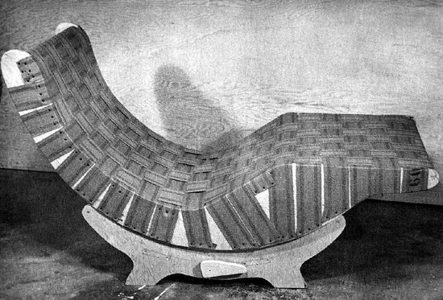

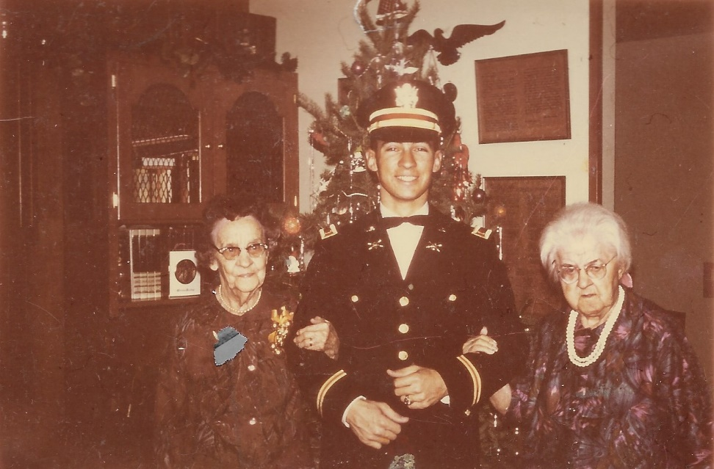
Pat with both grandmothers

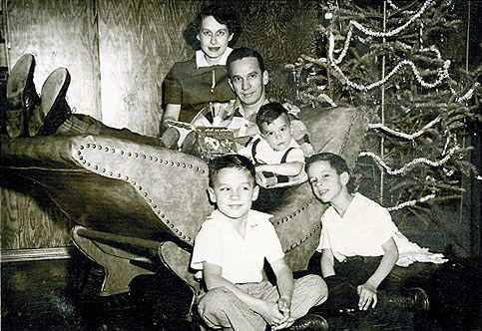

Dorr’s Business Career

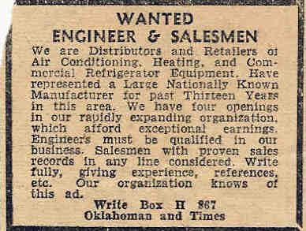
After the war Dorr went to work for OG&E as a Mechanical Design Engineer specializing in air conditioning. The boys liked it when he would bring home "Redi Kilowatt" pins. In February 1948 he responded to an ad in the newspaper for a position with C. Robert Ingram, a local air conditioning company. He had applied for a job with Ingram when he got out of the war but for some reason ended up working for OG&E. He started as a sales engineer making $400 a month. He loved to sell and this let him use his engineering background also. A year later he became the sales manager.
In 1953 Ingram wanted to get out of the contracting business and become the distributor for Chrysler Airtemp. He had been in the contracting business since 1936. He offered to sell the contracting side of the business to Dorr for $50,000. Dorr thought this was a once-in-a-lifetime opportunity and was anxious to take advantage of it. He knew he could never raise the required money, so he asked his lead sales engineer, Lewis Carter, Jr. to become a partner. That still required him to raise $25,000. With the cash he had and insurance loans, he had $10,000. He then tried to get Uncle Dewitt and Uncle Robert Trotter to loan him the money. He finally brought in A. E. Julius, the service manager for Ingram as a minor partner, and received backing from a group of about ten Oklahoma City businessmen including C. R. Anthony and B. D. Eddie. This is how Kent received his middle name. Lewis was lucky in that his father-in-law gave him the $25,000.

Thus Comfort, Inc. began November 1, 1953 as an air condition/heating contractor. They started out doing better residences, but later took on larger office and commercial buildings such as hospitals. The first year they leased a portion of Ingram’s building, then built their own 10,000-square foot building the second year on West Main. Ingram lost his Airtemp distributorship that second year and it was offered to Comfort. Thus, Comfort was the state distributor for Chrysler Airtemp as well as contractors. Ten years later they built a much larger 20,000-square foot building on NE 34 and later added another 15,000 square feet. Comfort did very well over the years and had a good reputation. We were able to take a number of nice trips, going to the various Chrysler meetings in addition to the trips he won. Both Ed and Dana worked at Comfort in the summers. Comfort used a polar bear, "Comfy, " as a logo for the company. Dorr asked me to make a polar bear suit which the kids would wear at home shows and other events.
In 1961 Dorr and Carter created a company called C&D Investments where they invested in a number of ventures. These included drilling eight gas and oil wells, building post offices in small towns and then leasing them back to the government, and building a 40-unit apartment building on NE 50. They also owned the Comfort building that is now leased to the state.
At the end of 1979 he sold his interest in Comfort to Carter and retired, although he kept his office in the Comfort building that they owned
on NE 34. He went to the office from about 11:00 to 4:00 each day, mainly to get out of the house and be around people. In 1991 he stopped going to his office in the Comfort building and created an office in the upstairs toy room. Later when his knees got so bad, he moved his office to the little nursery that we had off our bedroom. It did not give him as much room, but was much better for him.
Dorr always had some type of sideline business going, especially in the early years. He and a friend at work, Von Gotten, had the
Wallmaster franchise and cleaned walls, ceilings and grease ducts in restaurants in the evenings. He would call on a client during the day in a suit to sell air conditioning, and then at night wear greasy overalls to clean the ducts. They also built and sold cooling towers. Most large systems back then were water-cooled. Another venture was building leisure chairs.
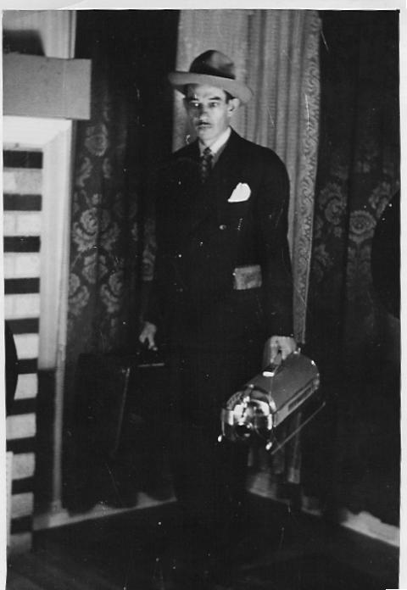
He set B. up in a small business called Dorco Sales. Dad bought them a house on North Western where B.’s family lived, and then built a small display room on the back of the house. B. then would go door to door selling room air conditioning units. They also sold covers to go over room units in the wintertime. Uncle B. was a wonderful man and would do anything to help anyone. He just did not have the knack for making money. He loved to play tennis and when he was young, he was a frequent visitor to the pool halls. In his later years he would go around to yard sales and other type of sales buying used clothing. The idea was he would then resell them at a profit or give them to the needy. The only trouble was that he never got around to selling anything. I believe he ended up with a garage full of clothing at the time he died in Norman.

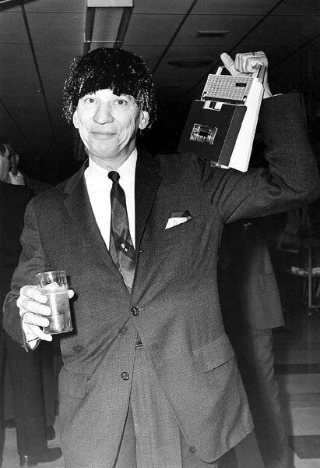
Dorr was never real active in civic or social activities in Oklahoma City. He was active in the downtown Lions Club, and in two breakfast clubs that met on Thursday and Friday. One was the Executive Association Club that had about fifty members, each from a different type of business. They were supposed to do business with each other. I always bought Rainbow bread because the Rainbow man was in the club. The other was the Tip Club that had about twenty members and you had to give a tip each week where someone could get business. He also went to the Sales Executive club once a month. He played poker once a month with a group of guys for years. For some reason Dorr enjoyed going to the Cattlemen's Cafe down at the stockyards and having brains and eggs. Pat has the original counter from the Cattlemen's Cafe in his museum in Stillwater.
Dorr was always pulling crazy stunts. When the Beatles were popular, he and three of his friends paraded through a downtown restaurant with Beatle wigs on. They carried a tape player with Beatles’ music playing. Another time when Ed was young, he put Ed in the front yard with a sign that said "$1.00 to Park" when his poker buddies arrived.
Dorr’s and my idea of a good time was to go out to Twin Hills Country Club after we got the boys in bed and sit out on the north porch and have a few drinks. (It was enclosed.) Also, whenever a big-name band came to town we would always go. Dorr also enjoyed going fishing; that was about the only thing I knew he could do without moving around. We went up to Lake Carl Blackwell quite a few times.

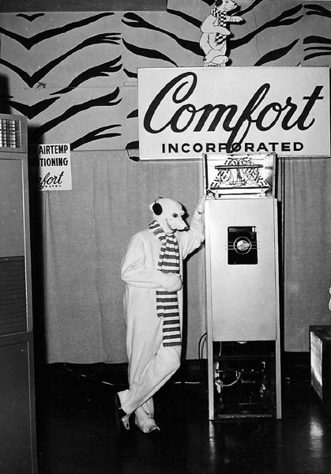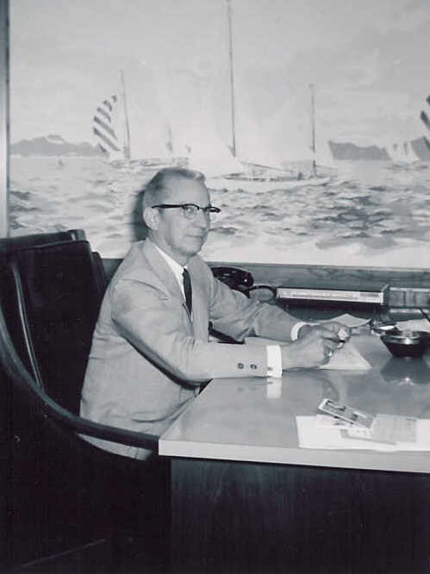

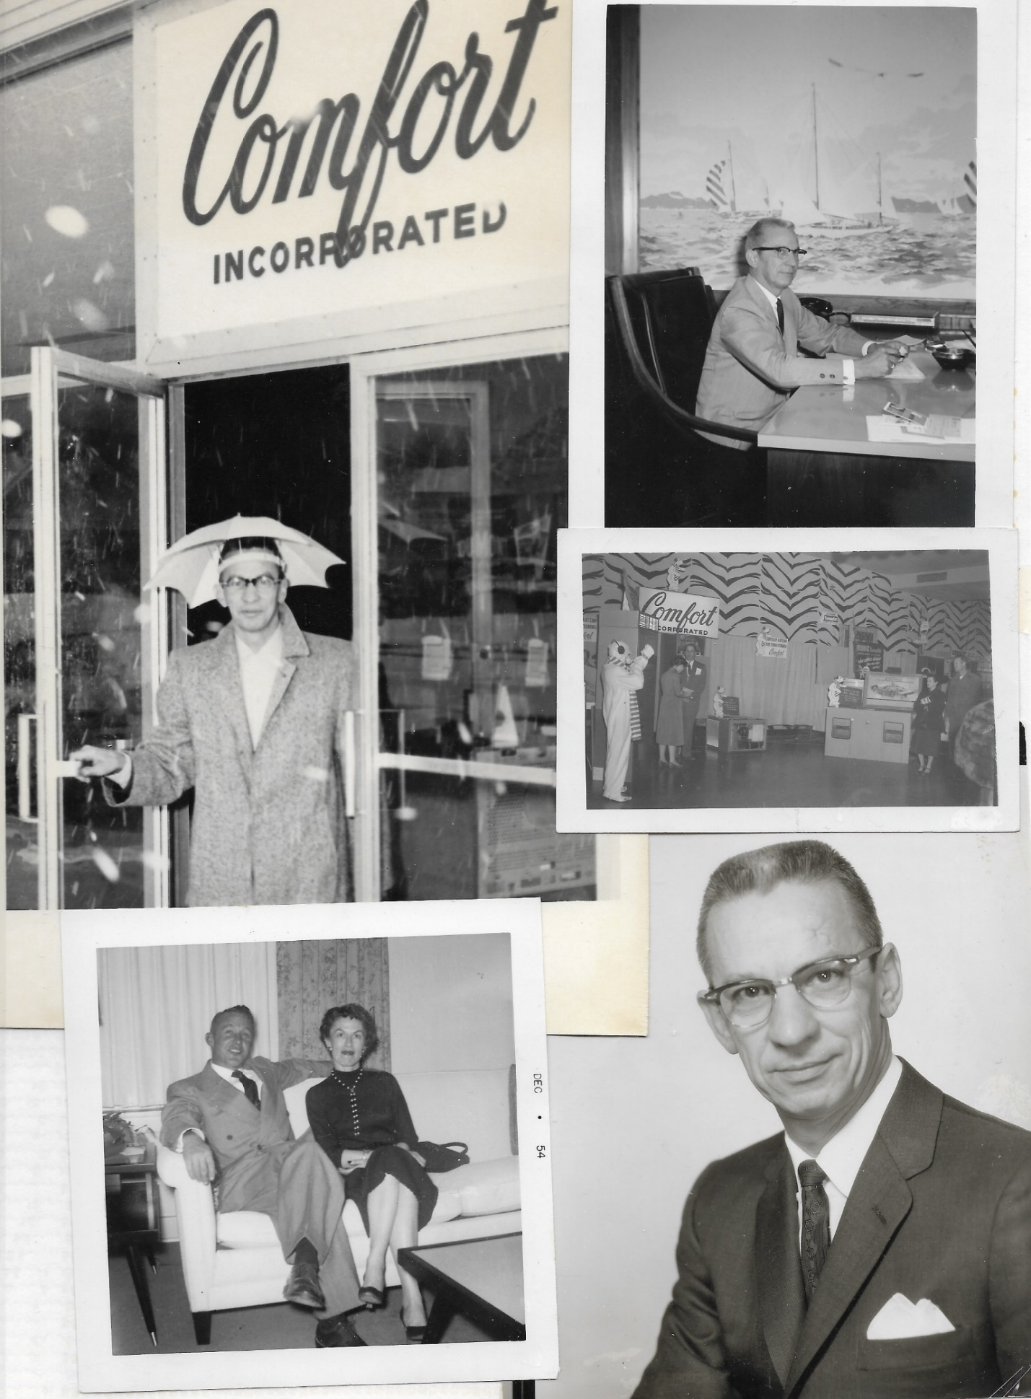

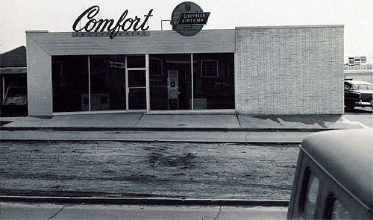

The Wildwood Years
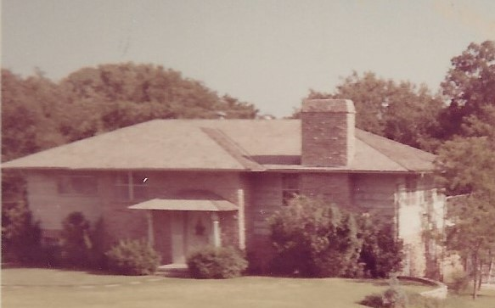
In 1958 we built a new home on a nice wooded lot in Wildwood on 52nd. I designed the house myself. Ed, Dana and Pat had their own bedrooms while Jon and Kent shared a bedroom. They were all downstairs. We also had a bedroom for Mother Dorr upstairs. She would visit us each summer and at every meal she would make biscuits. We moved to the house in November. The next year we added a swimming pool because some contractor owed Dorr money. Up to this point we had always driven out to Twin Hills Country Club for the kids to go swimming. The move did not affect Ed or Dana, since they were already in high school. Pat, Jon, and Kent ended up at Millwood.
In August, 1959 we all went to Colorado for a vacation except for Ed who went to visit Don and Lemma Perry. The same year we moved my parents from Perry to Oklahoma City to a house on NW 24th. Mother fell and broke her hip and my father would wonder off and get lost. We had to put him in a nursing home. We found a lady named Mrs. Taylor to stay with my mother. Mrs. Taylor was the only person who could control my mother. My father died in March, 1963. Mother died in March, 1968.
The next year (1960) we took our first major overseas trip, a Chrysler trip with five days in Paris and five days in Rome. I had been an art major in school and just to be able to see all the art work that I had studied was overwhelming. As a child I had an intense interest in maps and geography. Even after I was grown, I would dream of faraway places I would love to see, but really never expected to. Over the next few years, we were fortunate to go on more Chrysler trips, all of these were first class all the way. Most of the time we went with Carter and Joan, his partner. Some of the trips included Miami Beach, Majorca, Barcelona, Madrid, Athens, Naples, Pompeii, Venice, London and more. With five children at home this was amazing. I still marvel how we ever got out of town. (Believe me, it was not nearly as easy to go to Tulsa.)
In 1961 Dorr suffered mental exhaustion one summer and had 7 shock treatments A week before Christmas Dorr came home and said he was going to Las Vegas and wanted to know if I wanted to go. I was not about to let him go without me. We went to Las Vegas then we went on to LA because Dorr wanted to go to Disneyland. I felt so guilty about going to Disneyland without the kids that I just sat down on the curb and told Dorr I would wait for him. I did go in after he promised to take the kids the following year. So the next year (1962) the whole family went to Las Vegas and then to Disneyland. We took a helicopter from the airport to Disneyland. We flew out and returned on the train, stopping at the Grand Canyon.
We had quite a responsibility with three aging parents plus our children. I really wanted to be a good wife, mother and daughter. I nearly killed myself trying too hard. In March, 1963 I spent a month in the hospital recovering physically and mentally from a severe lung infection. The second day in the hospital my father died. It was truly a blessing; he was in terrible condition. I loved my father so deeply. The doctor was afraid this would throw me into a mental depression, but it did not. I picked up a book a few days later, Catherine Marshall’s "To Live Again" which spoke to me personally. I felt I was close to the kingdom of God, and yet when I came home, I let someone else’s attitude cause a resentment inside me that blocked me receiving from our Lord.
1964 seemed to be a busy year. Ed graduated from OSU; Dana had a summer job in Seattle at the Swedish Tumor Institute and Pat went on a Presbyterian bus tour. I suffered a traumatic experience in the unexpected death of my brother Don in June, 1964. Before dying he tried desperately to tell me something and I just could not understand him. I prayed so hard that I would not break down and could be a help to his wife. I kept saying, "Lord, please don’t let me cry." After I was back home, the grief that I had not let out got the best of me. It was the fourth of July and all the boys were there along with their friends. I would cook some food, then take a sleeping pill, then fix another meal, then take another pill. I blacked out as I leaned over to kiss Dorr who was in the lounge chair reading. As I straightened up, I blacked out and fell backward, dead weight against a sharp corner, splitting the back of my head. It was several hours later before I regained consciousness in the hospital. Before I regained consciousness, I saw my father and my brother very clearly, sitting on a simple bench looking very natural and peaceful. I only remember noticing their faces and the bench. They were looking at me with so much love and compassion. They were shaking their heads saying, "This is just not the way." Then I awakened.
In 1965 Pat graduated from Northeast and Dana graduated from OSU. That summer Ed and Pat went to the World's Fare in New York and then Pat left New York on a YMCA trip to Europe and a conference at Moimoi. In the fall we took Jon and Kent on a cruise. On talent night Jon gave his impression of Crazy Guggenheim. The boys loved the Italian waiter and wanted to bring him home with us.
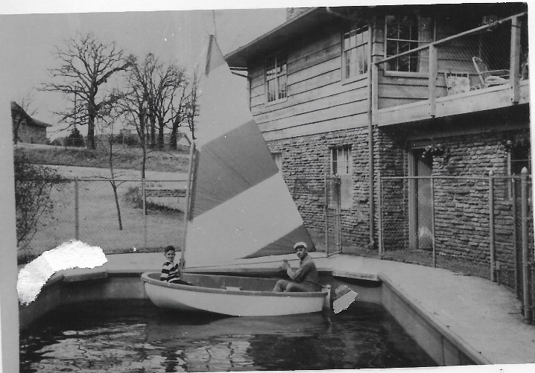
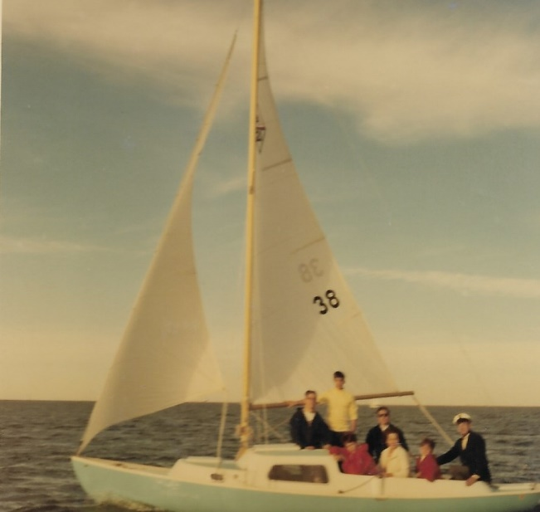
One day Dorr came home with a small Styrofoam sailboat approximately ten feet long. The boat had been used in some type of advertising display, filled with paint or something. He applied epoxy to give it strength. We would go up around Guthrie to some small lakes (ponds?) so he could sail his boat. In 1964 he bought a 19-foot centerboard boat, which meant you had to climb over the centerboard every time he tacked. I did not like climbing over the centerboard so the next year he bought a 21-foot keelboat that he kept at the Oklahoma City Boat Club on Lake Hefner. He loved to go sailing and would take anyone that would go with him. Sailing was not something I enjoyed, so I seldom went. I think Dana went with him the most and they would go to regattas around the state. He was the commodore of the Boat Club sometime in the 80’s. After the kids left home, he did not sail that much and finally sold it to Ed.
In January of 1966 Dana went into Army basic training and finished OCS in December, then went to Germany. In August Dorr, Pat, Jon, Kent and I went to Memphis to hear the Beetles. The next day we flew to Washington DC and visited all of the surrounding area. Later that year Dorr and I went to Mexico City and Acapulco and caught the sailfish that we had on the wall of the playroom.
Another special blessing involving a trip was while our second son was in the army in Germany. My mother had just died in March of 1968 after months of agonizing care, and I was so lonesome to see Dana. He had fallen in love with a little German girl and had become engaged to her. Being a mother, I could hardly wait to know her.
My husband let Kent, our youngest (who was then thirteen), and me go to visit Mike and to meet Anna-Marie. The other boys were working. This was the first time I had the opportunity to enjoy just one of our children alone since Ed had been a baby. Kent was full of ideas and energy. We bought a book, “Europe on $5 a day” and flew to Copenhagen, then on to Germany. It was really an adventure. No advance reservations; yes, we really used our book. Every other trip I had taken was very carefully planned and escorted. Dana took us around Germany for ten days. We loved Anne Marie, his girl.
At home we had a St. Bernard dog, so after leaving Germany Kent and I went to Switzerland and rode a postal bus up to Great St. Bernard Pass to get our dog Sidney a key to wear on her neck and to see the dogs there.
And our Lord was watching all the time. We were running low on money, and when we stopped in Paris on our way home, we decided we would go into a bank and asked to cash a personal check for $100. We had no real references and we were leaving the next morning so they had no time to check our bank. The fellow sat and looked at us a few minutes (I think in complete disbelief) and then he cashed our check. My husband and certain banking friends just can’t believe this. But there’s more.
We were flying to Chicago. Ed, who by this time was getting his master’s degree in Computer Science at Purdue, was to meet us and we were going to spend the night with him at Lafayette, then fly home the next day. Just before the plane landed in Chicago, Kent began to get a bad stomachache. He had an emergency appendectomy in Lafayette the next morning. What if that had happened in Paris or flying over the Atlantic? Anyway, we had some money. Praise the Lord!
On January20,1969 Pat and Kathy were married in Oklahoma City. It was a very happy wedding. They moved into student housing and continued their education. Also, Dana married Anna-Marie Becket in May in Wurzburg, Germany. Dorr and I went to the wedding. We flew to Luxembourg, took a train to Tititsee, then went to Wurzburg. Anna-Marie came at Thanksgiving and Dana started school at OU.

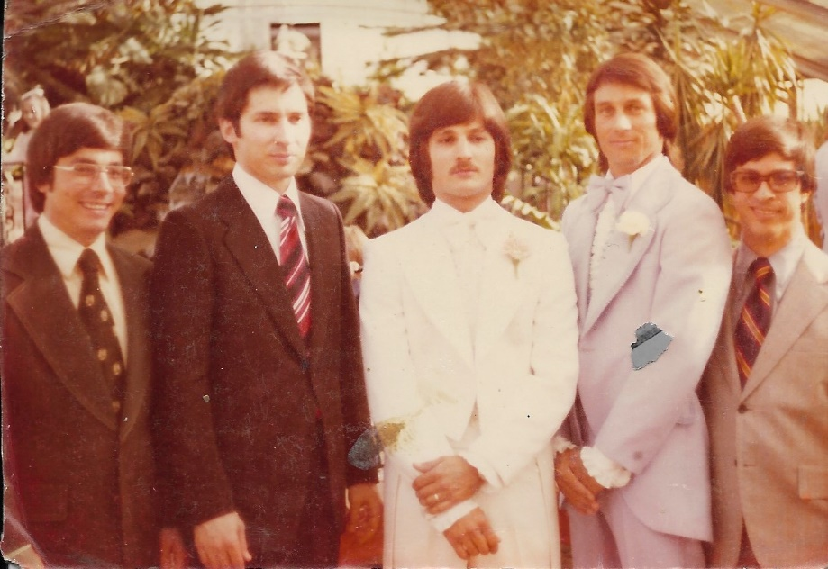

Finding the Lord
How many times have I thanked the Lord for letting me share those weeks with Kent, particularly the times when it seemed there would never be other times to share. For you see, he was in is teenage years and got into some trouble. We were shocked to find this was not too unusual in the school. This was our beautiful, handsome son who was so smart. He had some trouble with his knees in his growth process and the doctor didn’t want him to go out for sports, which he had always done. He was new at his school since we had just moved to the neighborhood. He was not happy. We were soon not very happy either. He was in rebellion the next two years and life was a nightmare. During these two years, three of his friends were killed violently in different kinds of accidents. I could do nothing. Kent and all of us spent two years in hell. You think this cannot happen to you and yours, but it can. Once again, I realized a situation where I could do little.
Dorr’s father had been killed in an accident six months before he was born. His mother never remarried. All he knew about being a good father was to be a good provider of the necessities and extras that he had missed having. Anyway one night in a dream I saw our first little house so clearly. Then I saw the house across the street from it. But there were extremely large trees in the backyard. The phrase “Cedars of Lebanon” came to me. As I was watching the trees they suddenly started falling across the street toward our house and completely crushed it to the ground. Then I awoke. At the time I knew it had significance, but I really did not understand. This was symbolically what happened to our family just a few years later. My husband suffered a nervous exhaustion one summer and I became ill for a month the next year. It was like a bomb exploding, shattering this close-knit family.
You know, my husband and I always had the crazy idea if we worked very hard, raised our family, and tried to be pretty good guys, we could reach our aim or a point up here somewhere that we were striving to get to. When we finally made it, we would just be able to sort of relax and have no more problems, sort of a vacation for the rest of our lives. Here we were getting close and the whole bottom fell out of everything. It was as if we were dead, but still living. We had always loved each other dearly, but now when we needed each other the most, we were killing each other with guilt, resentment and sharp words. We were so dead, so miserable and frustrated. You know, I didn’t leave God out of this; I cried over and over for help. I prayed every way I knew. But even though I always thought I was turning it over to Him (I wanted to), I was still holding on, desperate to do anything to help Kent.
My dear husband was devastated and found out he could have two drinks and it didn’t hurt so bad. This problem seemed to spawn another. Life was so miserable. It’s a familiar story, but the one you think just can’t happen to you. The hardest part was through this agony and frustration, when we should have been loving and helping each other the most, my husband and I were hurting, biting, blaming one another. These two people who had loved so deeply kept crying out the proverbial “Why, God, why?” We were so exhausted and full of guilt. We tried everything we knew, including panic prayer. This is when I found out Satan is real and not a figment of someone’s imagination. Satan (we began to recognize him) was having a heyday. I never knew whether I would continue to see my son alive from one day to the next. This is when I reached panic prayer, but I am admitting now it doesn’t compare with the prayer of faith. Things would be better, then worse.
Finally, one evening in September the family was gone. My husband was out of town at a meeting. I bought a new bottle of sleeping pills, bought a chocolate shake, went home, sat down, swallowed each pill one by one and drank my shake. Then I just went to bed and went to sleep. I had to turn my mind off for a while in quietness. My body felt like it was turning to stone and I know I couldn’t have made a sound, but there was no peace. It was like a tape recorder going off in my mind. I heard every sound I had ever heard in my life. I realized I had been tricked; there was no peace this way. What if these sounds went on forever? I know I couldn’t make a sound or move a finger, yet it was like my whole body cried out “God help me” and that’s just what He did. My husband arrived home earlier than he had thought and was able to call the doctor and help me.
The next day I was so grateful. I knew that I would never do that again. I might not know what to do, but it would be a God-creative one. I knew that I knew that God heard me. That meant He was really real, that He cared, and He helped me. I pondered on this for months and began to have hope. It was almost a year later when I came to the same utter exhaustion. I was alone in the same bedroom and I quietly knelt down and said, “Lord, I don’t know what I am doing wrong, but I want you to know if there is anything at all about me that you want, here I am. And I want to ask you for a miracle for my son.” I had no idea what would happen, but I know I had never meant anything so much in my life. I got up and went to bed and slept. I believed that my children were in safe hands.
The next day I was very conscious of my commitment although I had not mentioned it to anyone else. I just kept wishing there was some way I could show God how much I meant it. Now I know He knew, but I believed He knew it was important that I knew He knew it. So strange coincidences and circumstances started happening the next day that let me know the Lord was leading the way. I became expectant and watching to see Him in my daily affairs.
I cut out a little verse and pasted it on the bottom of the mirror in our bedroom. It is still there. It says “Never despair of a child. The one who you weep the most for at the mercy seat may fill your heart with the sweetest joys.” It has come true.
Almost a year later I found myself at the same point of exhaustion. Somehow, I sensed more trouble ahead and I wasn’t sure I could take anymore. I knelt down alone in my bedroom and very simply said, “God, I don’t know what I am doing wrong, I really don’t. But if there is anything at all about me you want, here I am. I am going to ask for a miracle for our young son. I believe it will happen and thank you now.” I didn’t know what this might mean; it was kind of scary, but I knew I had never meant anything so much in my life. I got up quietly, went to bed and slept. From the very next day the Lord used circumstances, people and His beloved word to start changing my life.
The next day was Sunday and I was driving across town to church. Just as I was almost at the May exit, a little voice quietly came across my mind suggesting I turn and go to Aunt Dorothy’s church. I was so startled I turned simply out of reflex action. I had never seen this church, but I knew about where it was located. Unlike our church, they had an “invitation” time. I went forward and the church prayed for me. On July19, 1971 I surrendered my life to God. I began to read and to study and I started of course with John’s gospel. And I know my God will never leave me or forsake me. I feel very loved and I still do. And I started on a fantastic journey! Still training.
The Lord is so good and gentle and how it must hurt Him that we turn away and have to learn in such hard ways. My husband and I were alone in our home for two months after Kent married, the first time in thirty-one years of marriage. This gave us a chance to minister to one another and heal our wounds. We had hoped for a grandchild for quite some time. We even had a tiny nursery off our bedroom. Now he was giving us a grandchild too, although not just in the way we had thought about.
In September I went to a Presbyterian conference called “A Revolution of Love” in Cincinnati. I dreaded asking Dorr to go but he just said, “If this is something you feel you have to do, do it.” Before the end of the first day was over it was full of people going Celebration. I had asked God to open my eyes and ears and let me be able to get the most out of it. It truly was a fantastic week. The people I met and shared with, the speaker I heard, the music, singing, sacred dancing. 3,000 people who loved God, His Son and each other! Each time I felt a twinge of loneliness something very personal and special happened. I had a beautiful dream. I supped with my Lord. Wednesday night we had the youth do our worship program. My life became life. This experience in Cincinnati is where I really met the Lord face to face and realized my life would never be the same again. It gave me a whole new perspective on life.
There were many more Christian conferences to follow the Celebration. I started traveling quite a bit around the world to different Christian conferences. These trips included Europe, Israel, China, Taiwan and other locations. I made a lot of long-term friends over the years and was able to meet leaders in the Christian evangelistic community. I was able to take some of the grandchildren on some of these trips. Chris went with me on a couple to Hong Kong and Australia. Dustin went with me to Australia and Tim went with me to China. I also went to Disneyland with some of the grandkids.

Congress on World Evangelism – Lausanne
Early in February 1974 my husband and I received information about the Congress on World Evangelism to be held in Lausanne, Switzerland in July. They needed money for third world participants to be able to come. Also, they needed prayer partners for the different countries. After some discussion, we responded. Of course, the prayer commitment kept it somewhat fresh in my mind. But by June it was in my consciousness so much I wanted to shake it off. By two weeks before the Congress was to convene, I felt like I had the itch or a case of hives. I was being needled. Finally in desperation I asked, “Lord, you couldn’t possibly want me to go to this, could you?” I had never had the experience of such profound silence. I knew, I knew that was just what He wanted, and I had not been listening.
Somehow, I had never seen myself personally connected to the Congress in any other way than the way we had already responded and I had somehow closed the door there. I had been learning that I might be uncertain of the next step, but I’m always certain of God, so I’m to do the thing at hand.
Someway I had saved the receipt we had received after sending the money in February. It had the name and address of one of the men on the planning committee. I knew at this late date he would already be gone, but it was all I had to go on. I wrote a letter asking if he could give me information about whether I could get into any of the sessions or be able to find a place to stay. I added that I believed the Lord wanted me to go. I didn’t dare talk to anyone about it. It sounded so unreal even to me. This was a momentous occasion in the Christian world. It was exciting but it was for invited participants. I was forgetting that it looked like I was getting invited for some purpose that I could not imagine. But I knew the Holy Spirit was speaking and waiting for my response.
I received an answer back from my letter on Wednesday before the Congress was to convene the next Tuesday. The man to whom I had written was already gone, but his secretary answered my letter. She couldn’t give me much information, particularly about a place to stay, but she thought I would be able to buy a ticket that would enable me to go to the morning and evening general sessions. The afternoon study and discussion sessions were closed to all but the specially invited participants. But she included in her letter the call slip that was sent to those participants. She didn’t have to do that, so I decided I should accept that as a confirmation to go.
That night my husband was at another meeting and there was no time to talk. The next morning, Thursday, as I was leaving to deliver Mobile Meals, the telephone rang. It was a close friend I had known since childhood. (Note: This was Thirza Brandenburg.) She lived in Stillwater now and was a recovering alcoholic. She had been drinking, she was crying and begging me to come and get her. Her husband was abusing her. I told her I would come as soon as I finished delivering the meals, which I did. Maybe some of you know that one has to stay very close to an alcoholic if you are going to keep them from finding liquor. So there was no time to talk to my husband alone. I was getting very nervous about it, yet I also had a strong sense of being called to obey the Lord. Saturday morning came and I was just waiting to catch Dorr alone at a quiet moment to tell him about what seemed to be developing. A friend dropped by, so she and my other friend and Dorr and I were sitting around the table in our kitchen drinking coffee.
I was surprised to hear this little voice come across my mind that I only hear occasionally when I need to respond quickly. The voice said, “Now is the time to tell him.” I silently protested “No, Lord, I need to have him by himself.” Again, I heard very firmly, “No, this is the time.” I was beginning to feel terrible. But as soon as there was a lull in the conversation, I looked across the table at my husband and blurted out, “Honey, I think I need to go to Lausanne, Switzerland on Monday.” Even I knew how ridiculous it sounded. He looked at me, turned red in the face, got up and said, “You are absolutely crazy,” and stomped out the back door.
I felt like I wanted to die. My “drop-in” friend soon excused herself and left. I tried to explain to my other friend what it was all about, but I knew she couldn’t understand either. Then I began to realize I was being tested. The sword of the spirit was coming down between everything I held dear and the Lord’s command.
Finally, I went to the phone and made reservations to fly to Geneva on Monday, putting it on our credit card. My husband wouldn’t speak to me the rest of the weekend. I was confused; he had not acted this way before. We had a young daughter-in-law and our little grandson (Note: Denise and Chris) staying with us at that time. Her husband, our son, was out of the country on a trip. Now she was the only one I had been able to discuss the trip with. She was trying to be helpful but I knew she was thinking, “Why is she going away and leaving us?”
Late Sunday afternoon I drove my friend, who was quite sober by then, back to Stillwater. I arrived back home about 7:00 PM. Until then I had not done anything toward getting myself ready to leave on the trip. So I hurriedly washed out a few things, ironed, shampooed and had just finished packing at 2:00 AM. Just then the telephone rang. It was our son saying he was on the way home, arriving at noon on Monday. My plan was leaving at ten minutes after noon. I heard in my spirit, “Now stop worrying. He will be here to help take care of things.” That reminded me that the Lord doesn’t give you something to do without providing the needs. This strengthened me.
The next morning, (the big day), my husband left for the office without saying a word. My daughter-in-law planned to drive me to a nearby bank where we usually had a small account because there was no time to go downtown. Then she would take me to the airport. I told the Lord if He wanted me to have any money at all it would have to be in this bank. Sure enough, there was $300, which I drew out in traveler’s checks. I prayed it would be enough to last the ten days since I had no idea, really, of what I would face in Lausanne.
I called the office from the bank to tell my husband goodbye and to tell him what I had just done. I was told he was not there, that he had gone home. I called home and asked what he was doing there. He said, “I came to take you to the airport.” I told him I would meet him there.
I got to hug my son as he arrived and I was getting on my plane. My husband acted very kindly, wanted to know if I had any money and kissed me goodbye. That really helped, but I knew the sword had split asunder what had been and what would be. There was a knowing that I had to turn loose of everything that I held close and was precious to me. I had to give it to Him. I wondered if I would ever receive any of it back. At last, I knew where I stood spiritually in a way I had not known before.
As I got on the plane in New York, I noticed an elderly man had been seated beside a young woman and her two small children. He looked miserable. I offered to change seats with him and he quickly accepted my offer. The young family got off at Zurich. I decided I had better move back to my assigned seat and start thinking about what I should do since Geneva was the next stop. I was wondering how I would get to Lausanne, which was about 35 or so miles on around the lake.
I had been in my original seat only about five minutes when I realized from what I was hearing that three people seated behind me surely were going to the congress. I turned around and asked them if that was where they were going. They said, “Yes, are you going there?” I answered yes but laughingly added that I wasn’t sure why and also that the only person that invited me was Jesus Christ. I shared that I was coming on rather short notice and didn’t have much information. The three people were a Dr. Baker from Wheaton, Illinois and two white women missionaries from the Ivory Coast and of course they were invited participants. They were so pleasant and told me, “Don’t worry about a thing. Just stay right with us. There will be a bus meeting all participants at the airport and will take us to Lausanne.”
After we were seated on the bus and on our way to the Congress, Dr. baker did a most beautiful and humbling thing. He took his briefcase, put it on my lap opened, and told me I could look through it. That way I could have an idea of what would be going on and the topics to be discussed. I wanted to cry because it was such a special thing for him to do. They wouldn’t let me out of their sight until we were all safely inside the large Palais that was buzzing with activity in preparation for the opening of the Congress the next day at 4:00 PM. I never saw them again. There were so many people!
I was able to buy a ticket for the full ten-day general sessions. The housing committee said they could have a room for me if I didn’t mind rooming with two German women. I was so tired I would have slept in a corner on the floor with anyone. One of the German women was with the German Salvation Army and was there only the first two nights. My other roommate was an attractive young woman in her early thirties. She was the editor of Billy Graham’s Decision Magazine in Germany. She was on the press corps at the Congress. Each night after the program was over, there was a press meeting concerning what had happened and what was to take place the next day. I would stay awake or wake up when she came in and she would tell me all the “behind the scenes” information. It was fun and very interesting. I soon understood she was a very busy person who had lost her father, a theologian, and was trying to help her mother and brother. She was so busy she was lonely. So, I just asked the Lord if He would shower her with love through me during those ten days. She received it like a hungry person.

Our room was only $10 a day (a special Congress price), but it had a large closet and bath. It was a very old hotel but was supposed to be the place where Lord Byron lived when he wrote “The Prisoner of Chillon.” It was on the lakeside in the Duchy area, the favorite tourist place. When I awakened that first day and opened the shutters at the windows, I looked out on the lake and the beautiful mountains in the background. I started crying and said, “Lord, you didn’t have to do it so good.” Also, each person with a room reservation had been issued a card good for free, unlimited transportation all over the city for ten days. Bus service was only a block away. By eating two scant meals a day my $300 made it. I was even able to share part of it.
On Saturday, the free day, many others and I went up in the mountains to Frances and Edith Schaeffer’s L’Brie. Part of the way there was by bus and part by train. While we were waiting at one of the stops, a Chinese reformed church pastor from Jamaica, New York and another minister from Grand Rapids asked if they could read the paperback book I had with me. I was amazed. The Chinese pastor was a speed-reader. He kept turning the pages and zowie - he was through!
Coming back, they invited me to sit with them on the train. They asked me all about my family, why I was there, etc. We shared quite openly. They told me they would be praying for my family and me. When we got off the train my new Chinese friend turned to me and without asking if I would like to, simply told me with much authority that he wanted me to meet him on Monday at one o’clock in the lobby of the Palais. He wanted me in a certain workshop. Besides being surprised, I also knew there was no way anyone who was not an invited participant with the proper credentials could get in those workshops. I thought he would be busy and probably forget anyway. But he was right there at 1:00 PM. He grabbed my arm and ushered me down several corridors, opened a door, pushed me in, caught the leader’s eye and said, “Take good care of her.” So, I was with this group the rest of the week. The topic of study and discussion was on suffering. I’m still learning much of what I heard there.
I usually stopped in the chapel that had been created in the Palais for the Congress at least twice a day to rest and be quiet. One day during the last week when I went in there was only one other person there. I soon realized she was sobbing uncontrollably. I couldn’t help but go to her and put my arm around her, patting her gently. It was obvious that we did not speak the same word language. She threw herself into my arms and sobbed and sobbed. As I held her and felt so much compassion, I began to get a feeling of that to which the Lord was calling me.
You see, there were so many people from all over the world. We each had to wear a tag denoting the language we spoke. There was every kind of costume and dress. I felt like I had been picked up and dropped down in the center of the world – and I knew it would not be the last time. When we all sang “Alleluia” each morning together (one word we all knew in praise to God), we knew we were family. I felt the Lord had just stamped “available” all over me.
When I came home, I had learned who I was. My family who had been so aghast when I left had a new respect for Who and what I believed. The Lord gave me back to my precious family to love them. He is putting us back together in His own way. Our young rebellious son has belonged to the Lord for quite a while. He is one of the kindest, most helpful persons I know and he is my friend. Our other sons have their own worth and their special place in our love and life. We are all in the process of learning unconditional love. It’s true that the Lord will use everything we’ve been through in both success and failure for identification with each other. I just have to quote I Corinthians 2:9-10!
“But as it is written, eye has not seen, nor ear heard, neither have entered into the heart of man, the things which God has prepared for them that love Him. But God has revealed them unto us by His spirit, for the Spirit searches all things, yea, the deep things of God.”
After fourteen more years, I have lost count of the “field trips.” Do you suppose one day when I was reading Isaiah my spirit was on fire and I raised my hand and said along with him, “Here I am, Lord, send me?” In the last seventeen years, I have gone with Him almost around the world. But He reminds me that the day I go with four-year-old Karly or Jessica to the zoo is just as important a trip. I agree. Or when Dorr and I are at home with one another is just as important. I agree. Also, our Lord reminds me that He is my only sufficiency. I agree. Then I knew He smiles when He whispers “Now go and be who you are.”

The Lansbrook Years
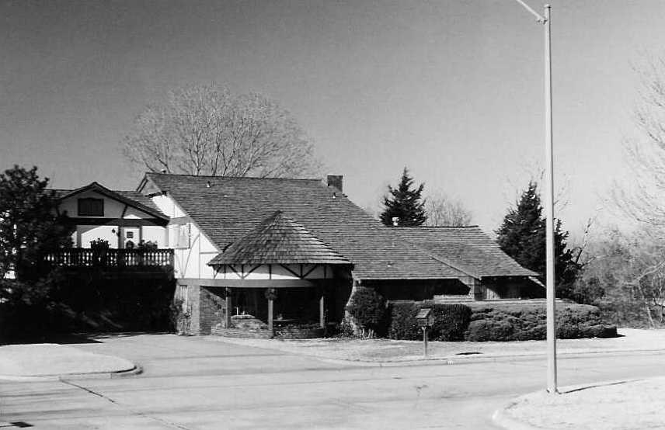
Kent went to Sunnyvale to see Ed, who had moved there after getting his degree at Purdue. Dana, Anna-Marie, two French travelers and I drove to California to see Ed and pick up Kent. Kent had left before we got there and had gone to Los Angles, so I flew back home. Anna-Marie went back to Germany in October; she just did not like the United States. Ellen died in the early part of July.
During spring break of 1971 Dorr and I, Kent and Jon met Ed (coming from California) in Hawaii. We went to all of the islands. I saw the covenant rainbow as we were going to the Honolulu airport. In August Kent and Denise were married in the Westminster chapel. Dana arrived that day from Europe in time for the wedding. Dorr and I were alone in our house for the first time in 31 years of marriage. This gave us a chance to minister to one another and heal our wounds. We had hoped for a grandchild for quite some time; we even had a tiny nursery off our bedroom. Kent and Denise moved back into our house for three months before Chris was born. This was another healing process for all. During this time Kent remodeled a little house that we bought them. On March 12 Kent and Denise gave us our first grandchild, Chris. I left two days later for my first Adventure in Living conference in Sorrento and Rome. I was home in time to start taking care of Chris through the daytime. In 1973 Kent, Denise and Chris moved to Ada where Kent attended East Central College. Pat was teaching at this college at the time. Dustin was born June 1, 1975.
Pat and Kathy had moved to Ada in 1972 where he taught accounting. On October 30, 1973 Kathy gave me my first granddaughter, Megan. Margie and Tim preceded her by a week.
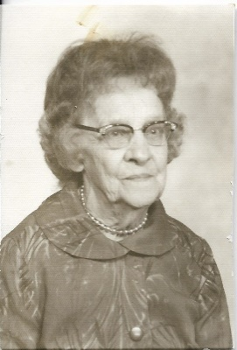
In January of 1972 Mother Dorr died. Dana and I had visited her earlier on the day she died. I had never heard her sing. She would whistle around the house, but I had never heard her sing. As we came into her room she was singing, “This is my story, this is my song, praising the Lord all the day long.”
Dana graduated from OU with a degree in mechanical engineering and in June Dorr and I took Dana to Phoenix, where he attended the Thunderbird International School of Management. We then went to California to visit Ed. We got to meet Margie, whom he met at a Sunday School class at Peninsula Bible Church in Palo Alto. She has big brown eyes and long brown hair. She is a little shy, but really has a quick, warm personality. When I met her, I felt sure she was the one. They were married in August. Only the parents were going out to the small wedding. Two weeks before the wedding I heard this little voice coming through saying, “The Lord would like for all of you to go to Ed’s wedding to give glory to God for what He is doing in Ed’s life. He will honor this.” I was sort of overwhelmed, and said “That’s fine, but you know I can’t do anything about it or they will just say Mother’s at it again. It’s great with me, but you are just going to have to do it. I’I'll just be prepared and ready.” I felt I should tell my husband, but I was chicken until the next afternoon. It definitely had been decided earlier why it was not particularly important for everyone to go. When I told him, he just looked at me and said, “If all of those kids are going, I don’t want to go.” (It was a bunch.) So absolutely nothing was mentioned about the wedding for two days. Boy, what a test of waiting, particularly since time was running out.
The next evening, my husband breezed in from work like a different person, so happy, relaxed and talkative. He said “Say, I stopped by Kent and Denise’s to leave a package and you know, they said they would like to go to Ed’s wedding.” I said “Oh, really.” Inside I was saying, “Oh, oh, Lord here we go.” I didn’t have time to tell you how it all happened, but it was hilarious! I was exhausted from answering calls and making travel arrangements by the time I got on the plane four days later. Anyway, people kept coming in by car and plane all week until by the evening before the wedding everyone in our family and Margie’s family was there. It was a simple ceremony with no attendants in a medieval-like chapel. It was a beautiful sun shining day. The words the minister said all referred back to counseling they had been having with him for several weeks and mainly centered around 1 Corinthians 13. When he finished, Ed looked at Margie and said, “I love you.” And that did it, we cried buckets of joyous tears.
Jon and Carolyn were married May 25, 1974 and he received his degree in accounting from OU in May, 1975. The marriage lasted until 1977. In August Dana and Elsie came from Brussels and were married in our home by Dick Hershberger, who was the pastor of Westminster Presbyterian Church. They flew back to Brussels the next day. Dana came home in April and Elsie came in June. Marc, Elsie's son, went to live with his father. Elsie's mother came with her grandson, Daniel, for Christmas.
In January Dorr and I went to Maui with the Airtemp VIP group. Then I went to Scotland, England and Switzerland with Adventure of Living. Visited Stonegate, then went to see Dana, Elsie and Marc in Brussels. Dorr and I went to Greece in October.
Kent and Karen were married March 20, 1977. Dorr and I, Jon, Kent and Karen went on an Airtemp trip to Switzerland in October. Kent and Karen have given me three more granddaughters, Karoline, Karly, and Kamille.
Dorr and I went to Israel with Pastor Robert Wise in February. I went on my first crusade trip with Nora Lam in August. The trip included Taiwan, the Philippines, and Japan. This was the first of many trips to China. In October Dorr became quite ill with a liver problem. He lost a lot of blood and the recovery was slow. In January, 1979 Dorr and I flew to Maui for a rest and stayed at a condominium near Keahi. Met friends from Seattle that we had met in 1976. We were with our friends, Andy and Margaret Newcomer, and visited the Japanese Congregational church they were pastoring. Fog delayed our departure and we had to spend the night in the airport. I also made a second crusade trip in July to Taiwan, Korea and the Philippines.
Amber was born May 3, 1979 and I went to Stillwater to care for Megan. In May I had a bladder operation and got my first doll house, fun! In 1980 we celebrated our 40th wedding anniversary in June. The kids had a home party for us and Jon even had T-shirts made. We then went to ShangriLa with Carter and Joan. I took Chris and Dustin to Disney World at spring break. The following year Chris and I went on a crusade trip to Taiwan, the Philippines, Singapore and Hong Kong. Then in 1981 I took Tim and Diane to Disney World. We also went to Epcot.
Kathy, Megan, Kay and I went to Kimberly’s (Sterling and Rae Donna Jones's daughter) wedding in Houston on January 2, 1983. Fran, Dorothy and I took a trip to Israel at Easter; it was a wonderful trip.
Ed, Margie, Tim and Diane came for a visit the last of August, 1984 on their way to Pennsylvania. EDS had transferred Ed to Pennsylvania. In September Dorr and I flew to Harrisburg and visited them. In 1985 Tim and Diane came for a three-week visit. Ed came for five days; good visit. The kids and I drove to Texas to see their other grandparents, Lemma Perry and friends in Plano. Chris and I went on the Oklahoma Friendship Force trip to Australia.
In early 1991 Dorr became desperately ill and was diagnosed with cirrhosis of the liver from all of the heavy drinking he had done over the previous ten years. After this incident he stopped drinking for a while and regained a lot of the energy and confidence that he had lost. He moved his office from the Comfort building to the little room we had for the grandkids upstairs. He got interested in the computer and even helped Jon build a new home. He spent time keeping up with income and expenses and about a dozen investments in stocks, bonds and mutual funds. He watched quite a bit of TV including 60 Minutes, Rush Limbaugh, old 1940’s movies, Perry Mason, Murder She Wrote, Father Dowling, Sherlock Holmes and Matlock. He would walk the dog every day at 4:00.
Dorr and I traveled extensively over the years to Europe, the Middle East, and Hawaii. His last trip abroad was in 1980 when we to see the Passion Play in Germany. In 1994 we went on our last trip to Las Vegas. When Dorr got off the plane his knee had gone completely out and it was a quarter of a mile from the gate to the baggage claim, so we got a wheelchair and I pushed him. We stayed at the Vegas World on the strip. We took taxis and visited the other hotels. We took it easy for the first couple of days. The amazing thing was Dorr never had a drink the whole week we were there. I enjoyed playing the slot machines while Dorr played blackjack.
The really big show was Ziegfield and Roy, the illusionists. They came from Germany and had been together for twenty-five years. Their show is so big that the Mirage built a twenty-million-dollar theater for it. This was our last night so we went there. When we called, they only had 40 seats left for the 11:00 show. Because of Dorr’s knees we got first class treatment everywhere we went. They even gave him a stool at the head of the line to wait for the opening, then a table right in the middle. We both agreed that this was the biggest thing we’d ever seen.
We got back to our room about 2:00 and we were so exhausted that we went to bed thinking our departure was at 3:45 the next day, which really was our arrival time in OKC. Thus, we missed the flight and took a later flight that arrived in OKC around midnight. Kent picked us up and we got home around 2:00. We were so exhausted we didn’t go out of the house for several days. I did not think I would enjoy this trip but it turned out to be one of our best.
In his last few years Dorr enjoyed writing a number of letters trying to reach members of his LST ship. Dorr enjoyed writing letters to his old friends and would write them nearly every month. Dorr’s pastimes the last few years here at home were working on the computer and watching TV. He had four color sets with cable, three with VCR. He would tape the late-night shows on NBC and CBS and watch them the next day along with murder mysteries, Rush Limbaugh, and movies. In his early years he loved photography and played golf and tennis. He also enjoyed fishing.
In March, 1995 Dorr went into the hospital with pneumonia. He died at home on July 13, 1995.

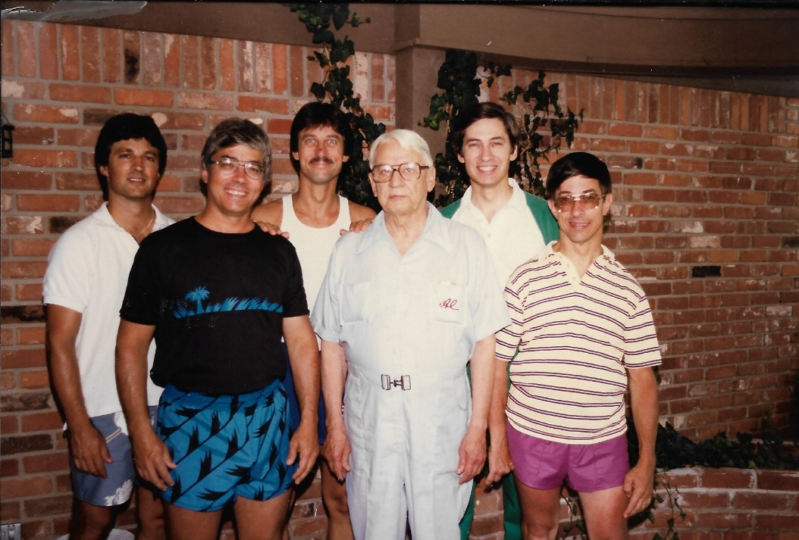

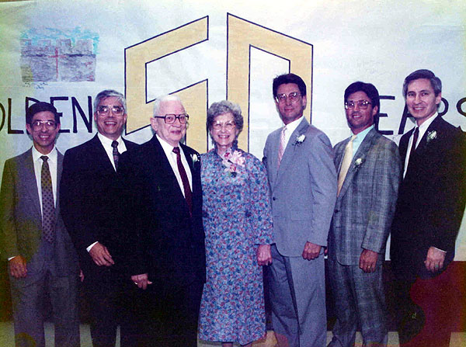
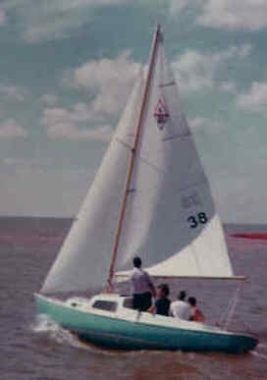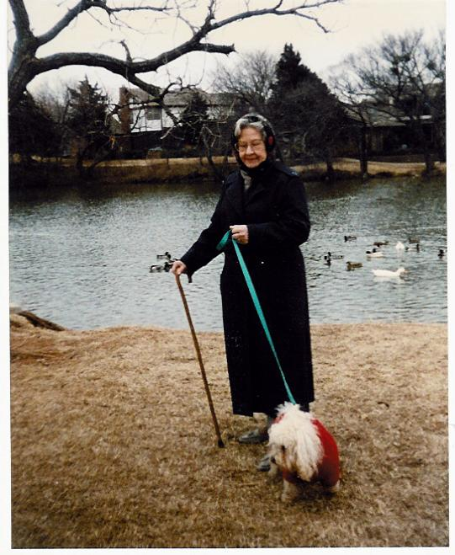
Dad's last sailboat Mom walking Hubcap

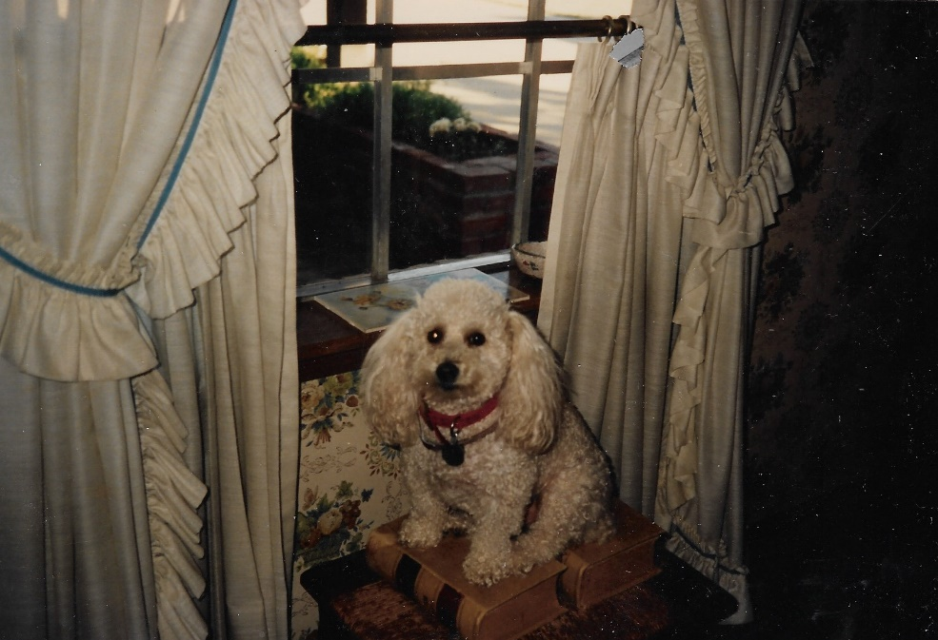

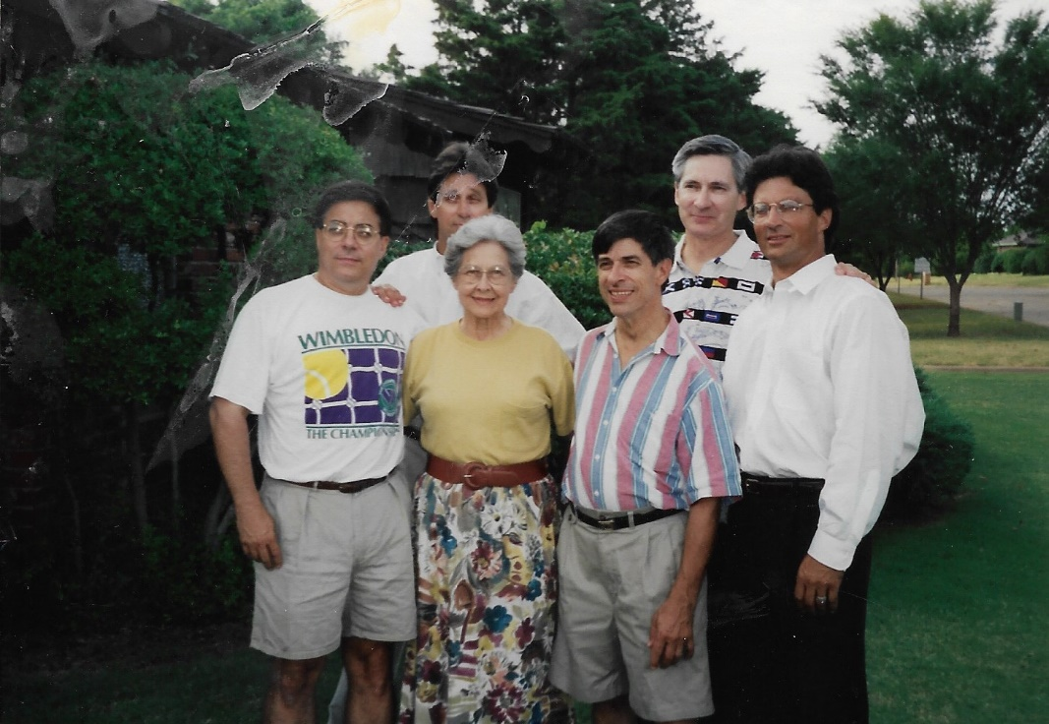

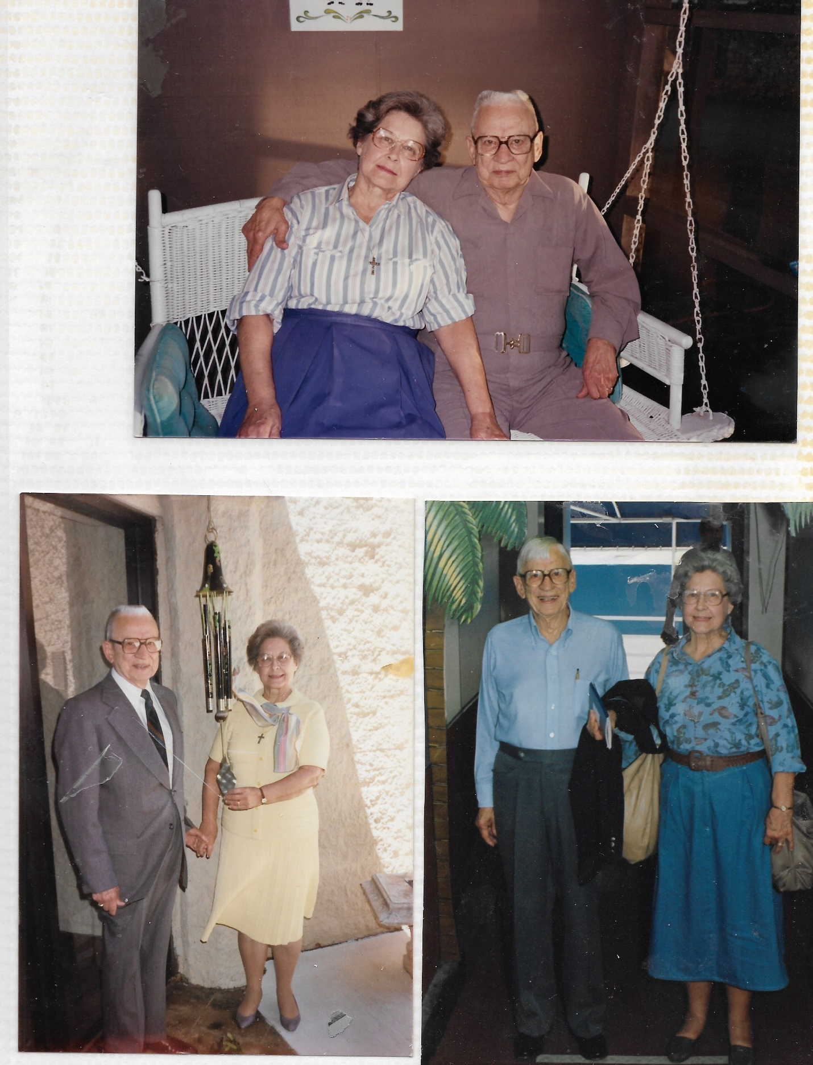

Renaissance in Stillwater
In 2002 the boys helped me move to an assisted living home in Stillwater, the Renaissance. I hated leaving the home I had lived in for over thirty years. The last few years I really enjoyed the screened-in porch we had that overlooked the lake. I took many a nap out there. Dana helped me the last few years and I know without his help I would not have lasted as long as I did there.
I have everything I need here and it is a nice place. As long as I have Missy, my dog, I guess it really does not matter. The boys even put a doggie door in and built a little fence around my patio so Missy can go out when she wants.
Maxyne lived at the Renaissance for five years, the last two in the Alzheimer's facility. On September 31, 2007 she went to be with the Lord.

